**Lab 1 – Designing ML Solutions & Exploring Emerging AI/ML Trends**

**Theme: From Idea to Impact – Exploring Cloud AI/ML through Design and Innovation**

**Objectives:**

* Introduce students to Azure Machine Learning Studio through a **design thinking approach**.
* Familiarize students with AI/ML pipelines using **low-code tools**.
* Foster **collaborative solution design** for industry use cases.

**Prerequisites:**

Curiosity and willingness to explore design and emerging AI topics collaboratively.

**Updated Lab Activity Overview**

**Part 1: Design Thinking Session (Team-Based, 30 mins)**

**Goal:** Identify a real-world problem that can be addressed with ML.  
  
**Activity:**

1. Form small groups (2–4 students).
2. Use paper to ideate on the following:
   * A use case in **healthcare, finance, environment, education**, etc.
   * Who is affected, what data might be involved, and what a successful outcome looks like.
3. Document your idea using a simple **Problem-Solution-Impact** format.
4. **Problem Statement**:

The financial market reacts quickly to news. Investors often make decisions based on news sentiment. Right now, there is no good way to analyze and predict the impact of news in a structured and measurable way. Both individual investors and institutions find it hard to understand how market sentiment will affect prices.

1. **Solution**:

We will analyze the sentiment of financial news using tools like VADER or Azure Text Analytics. This gives us a sentiment score. Then, we will combine this with past market data (like S&P 500 returns) to train a machine learning model. The model will try to predict the market return for the next day.

1. **Impact**:

The system can help investors make better daily decisions (Buy / Hold / Sell) using sentiment signals. It can also help quantitative teams build strategies and help institutions with risk warnings and position management.

**Part 2: Azure ML Studio Walkthrough & Setup**

**Goal:** Create a workspace and understand the ML workflow.  
**Instructions:**

1. Create an Azure ML workspace (Canada Central).

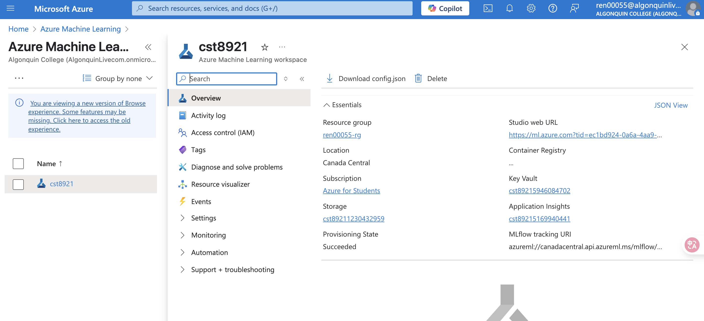

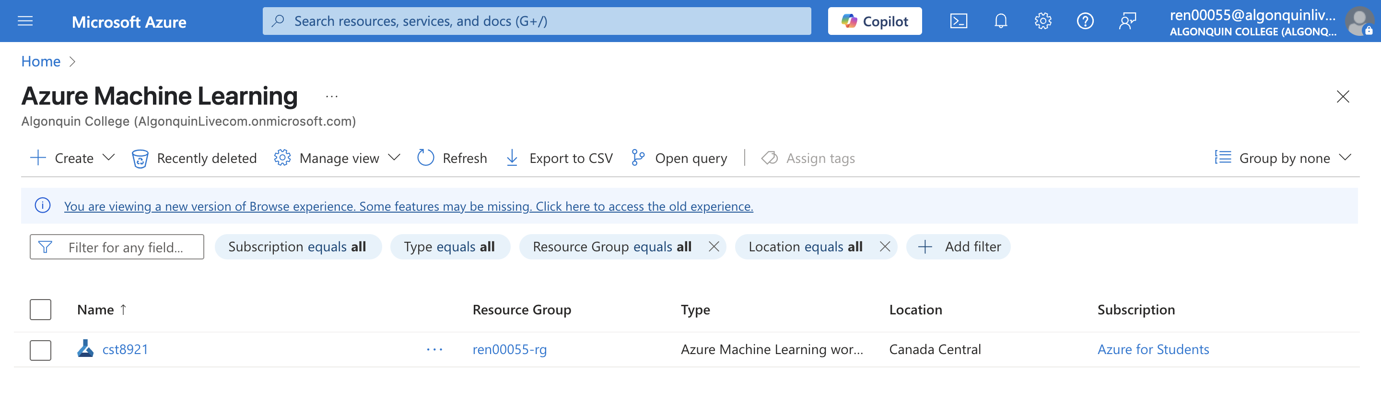

1. Explore the **Authoring, Assets, and Manage** sections.

**Authoring**

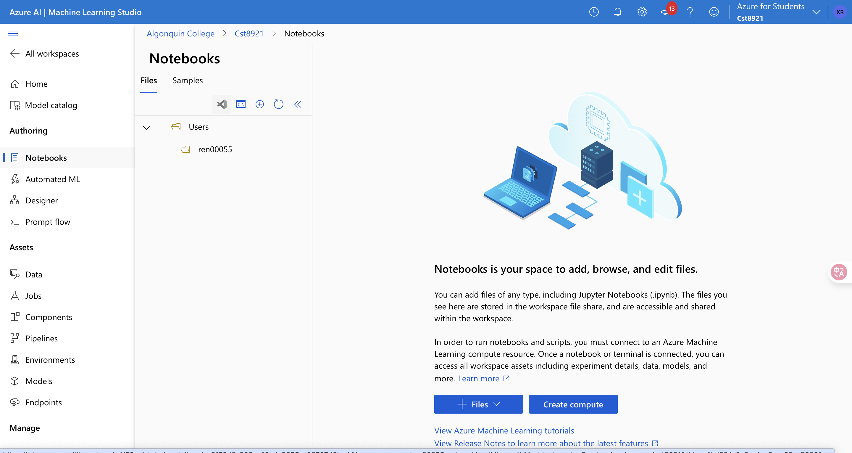

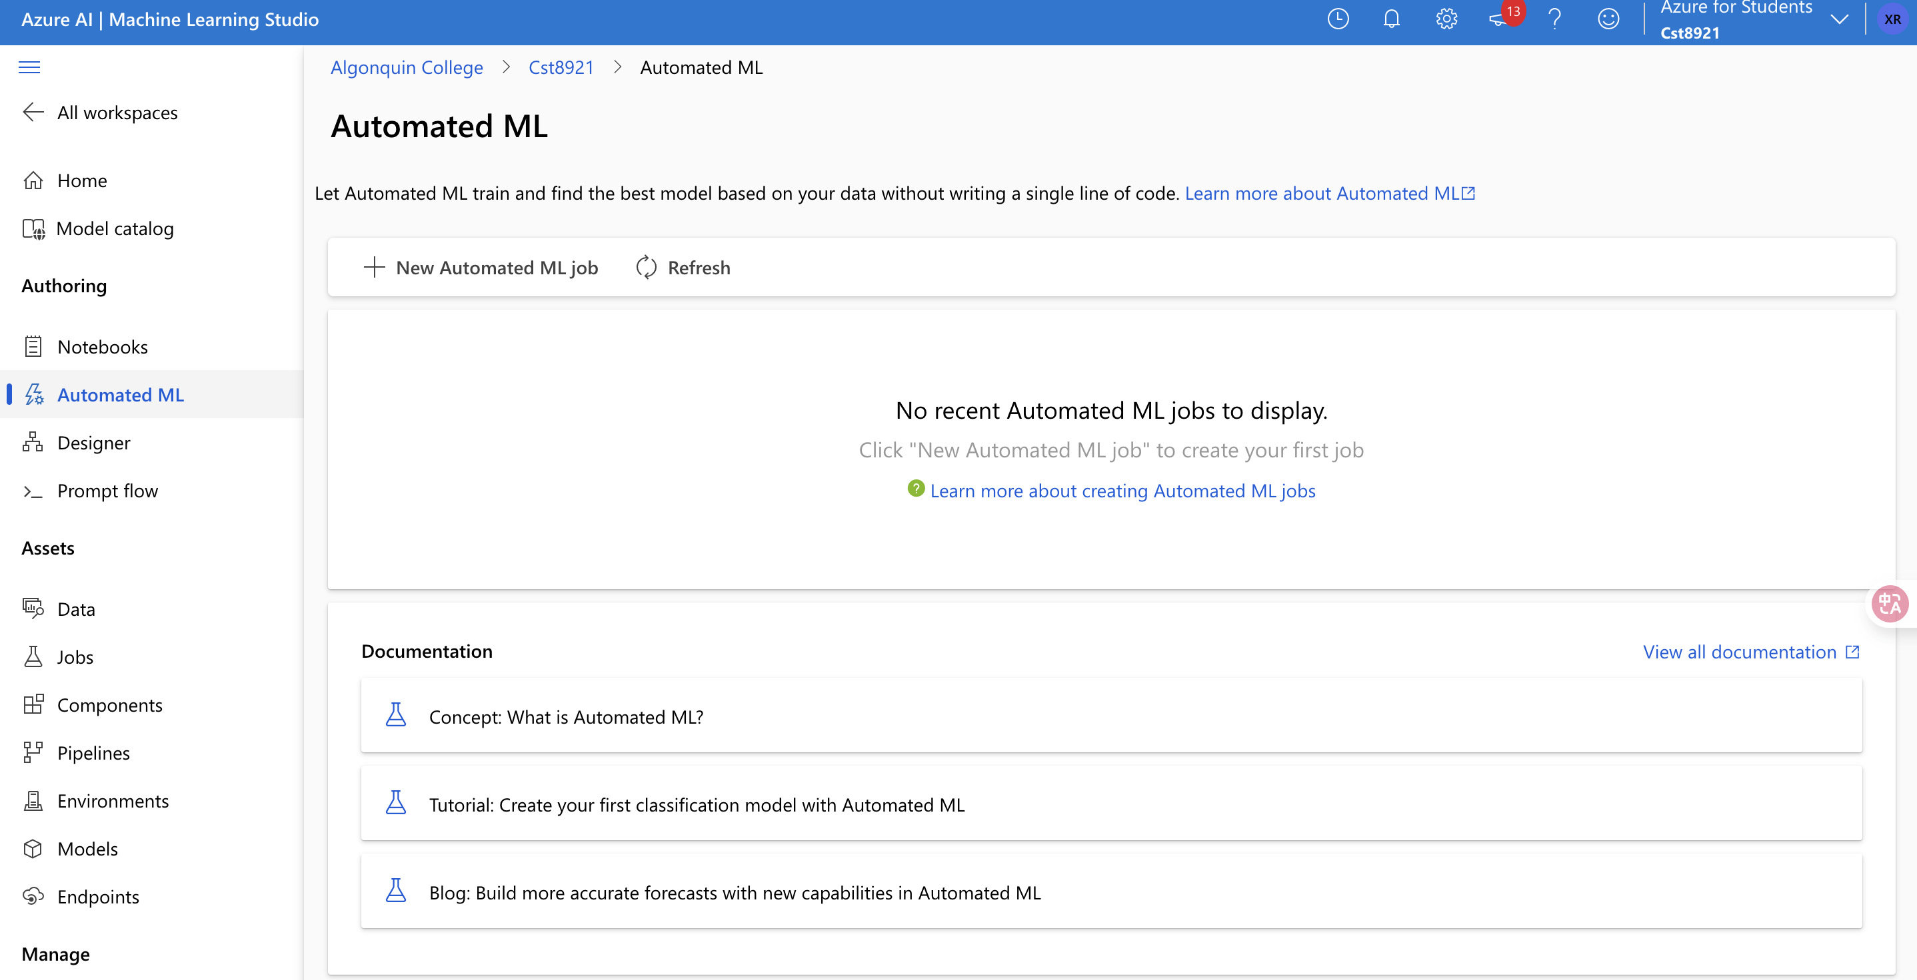

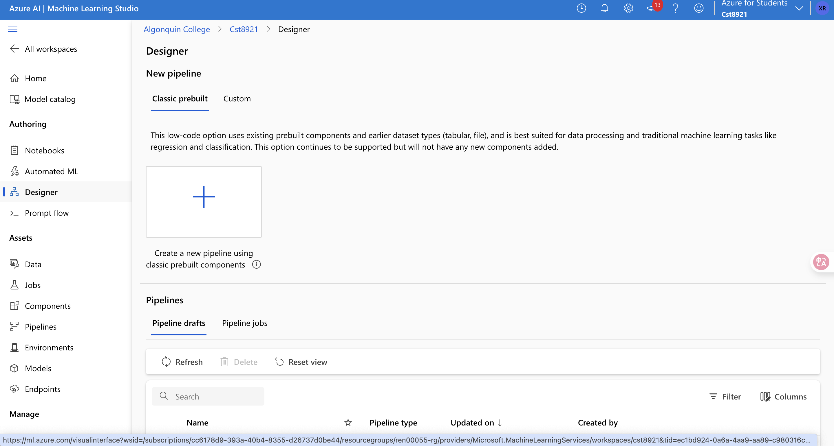

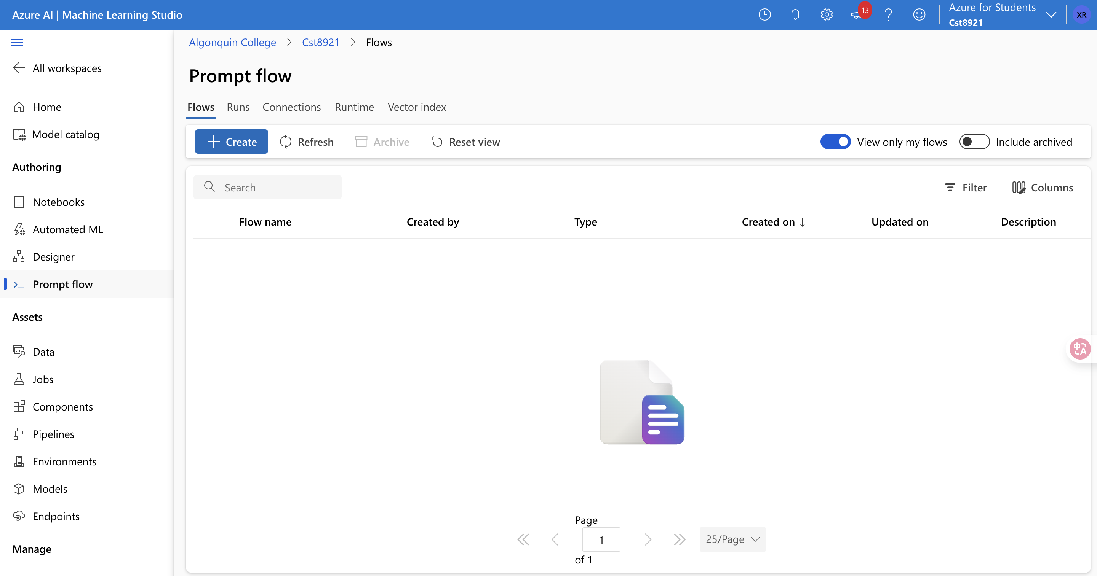

**Assets**

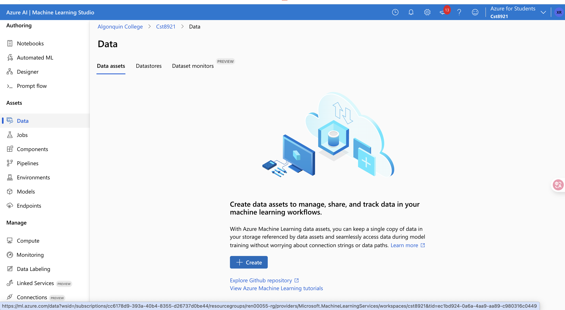

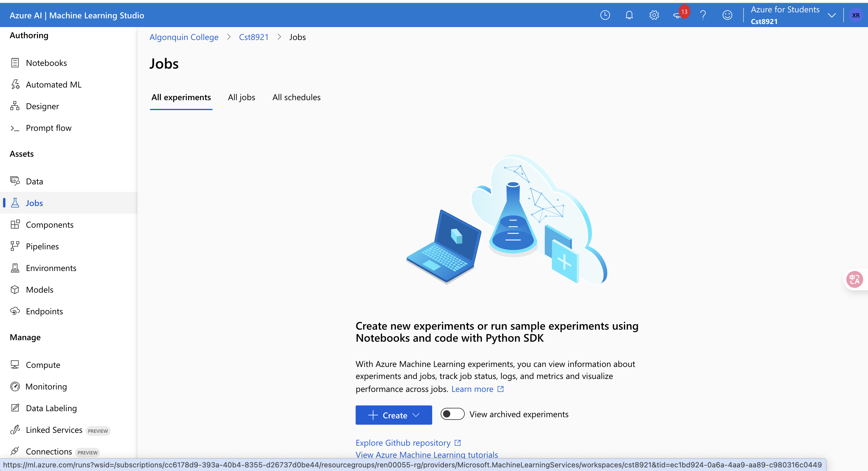

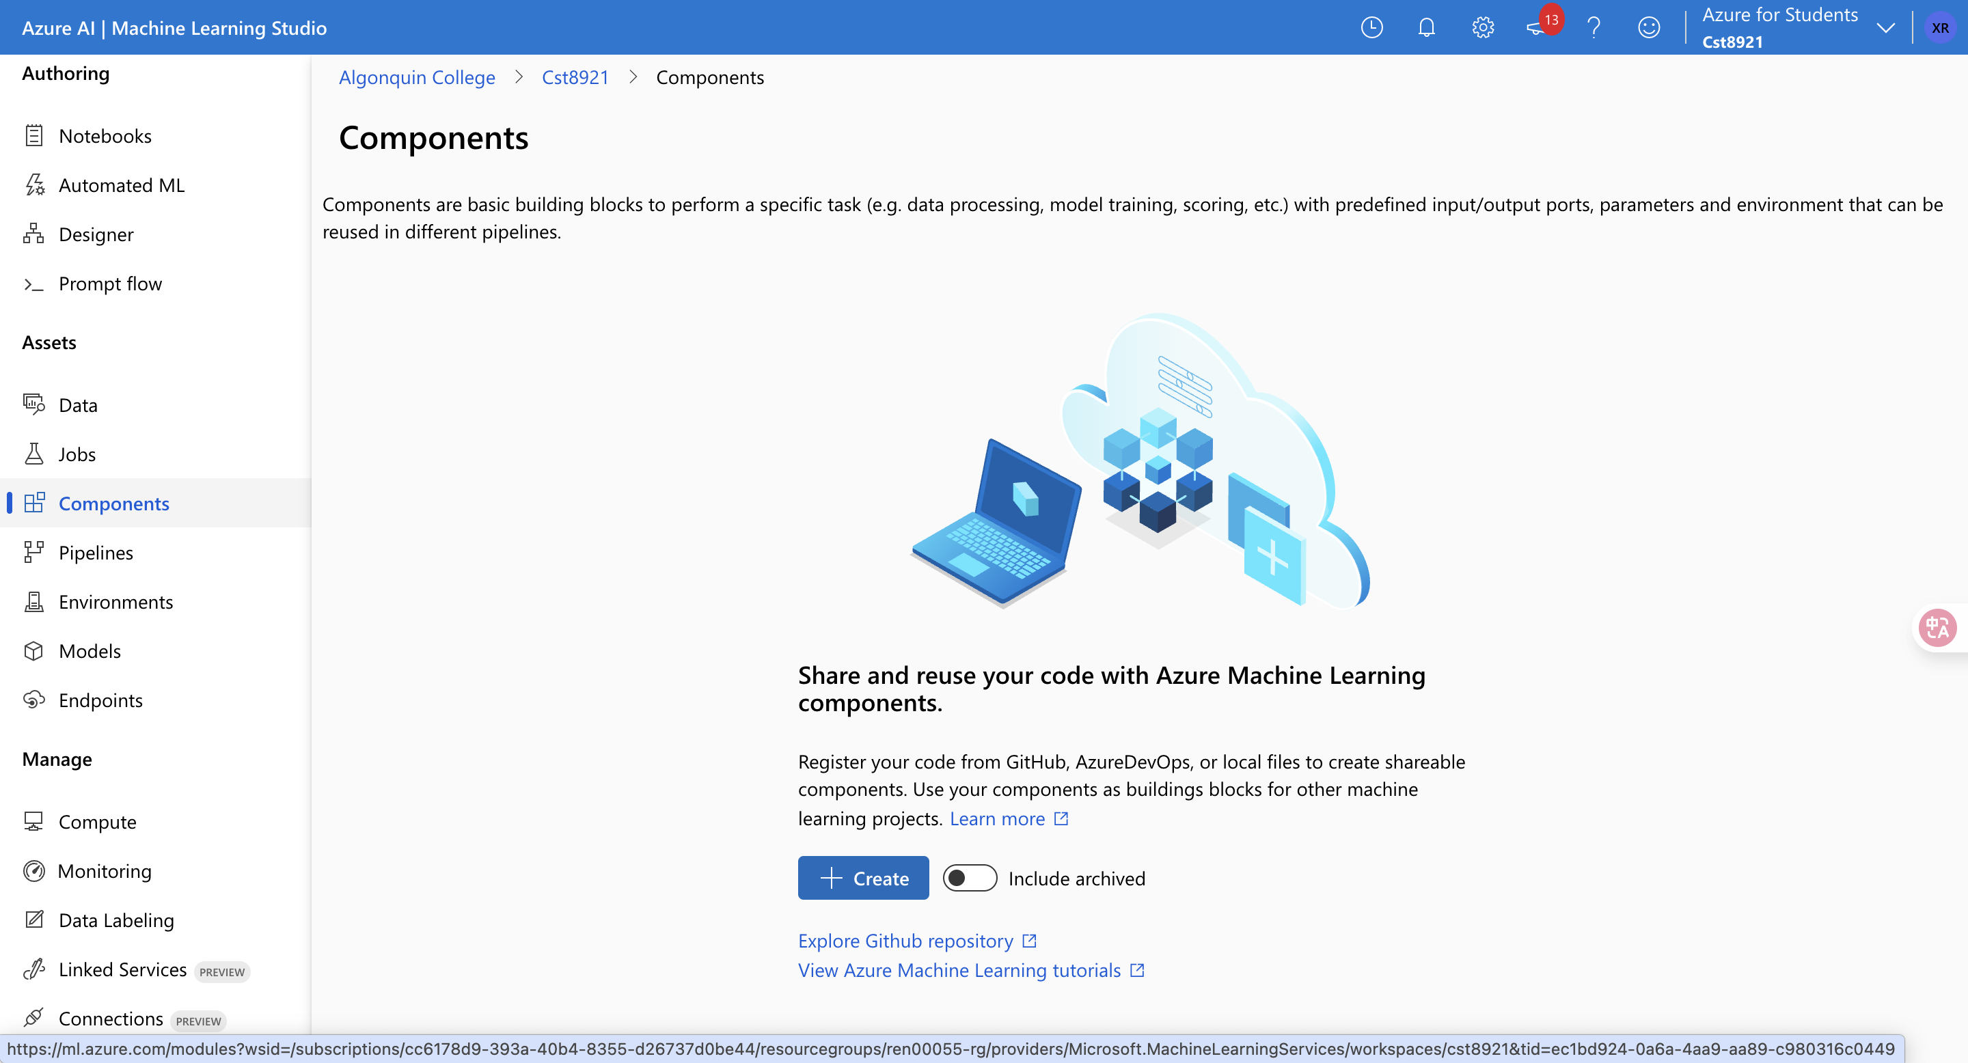

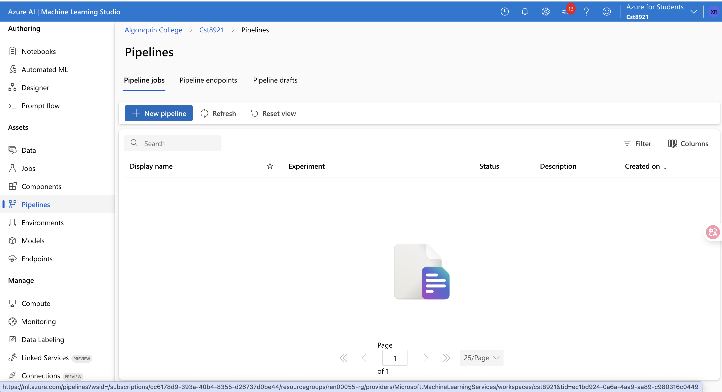

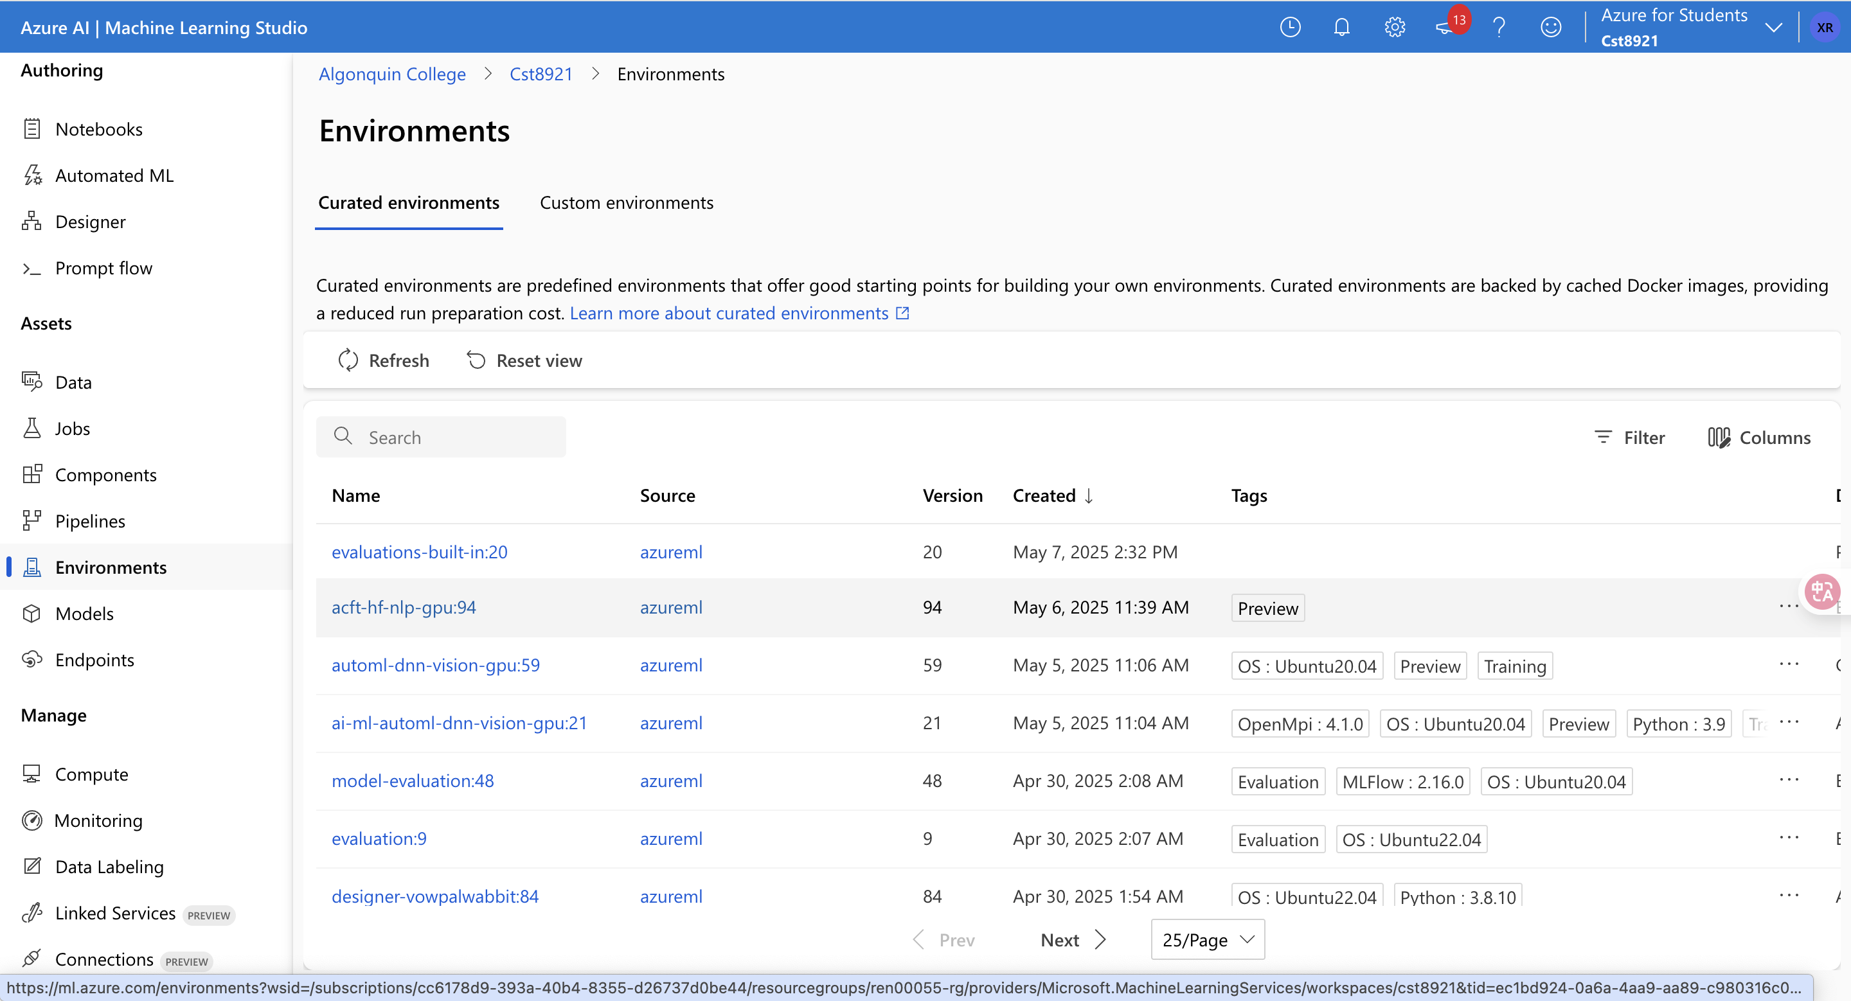

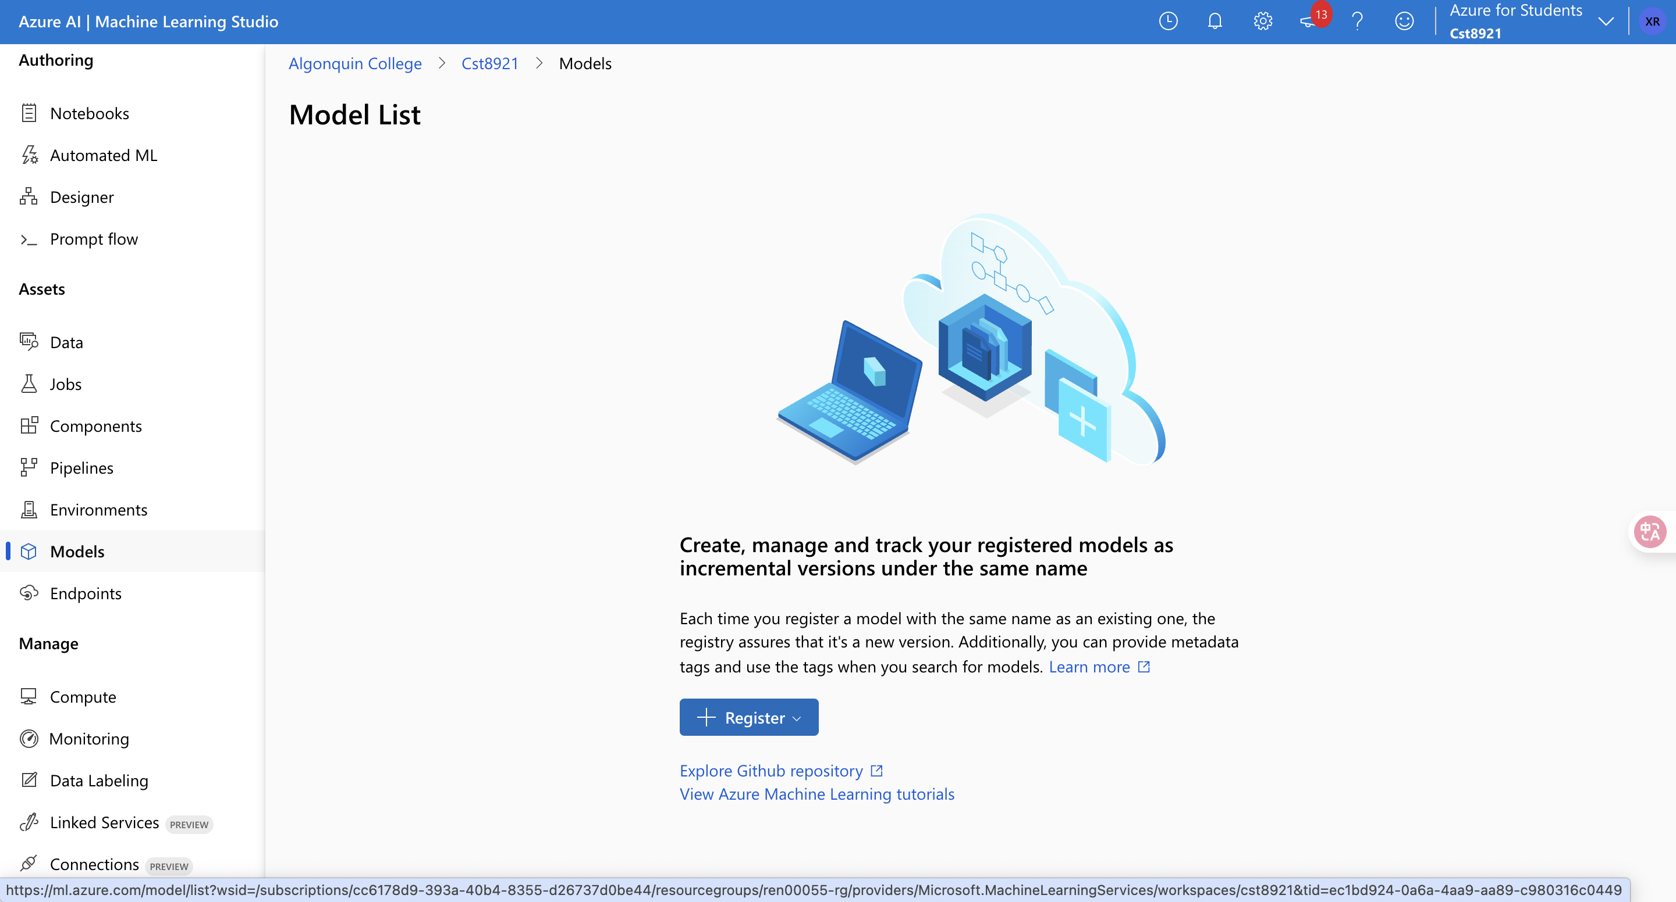

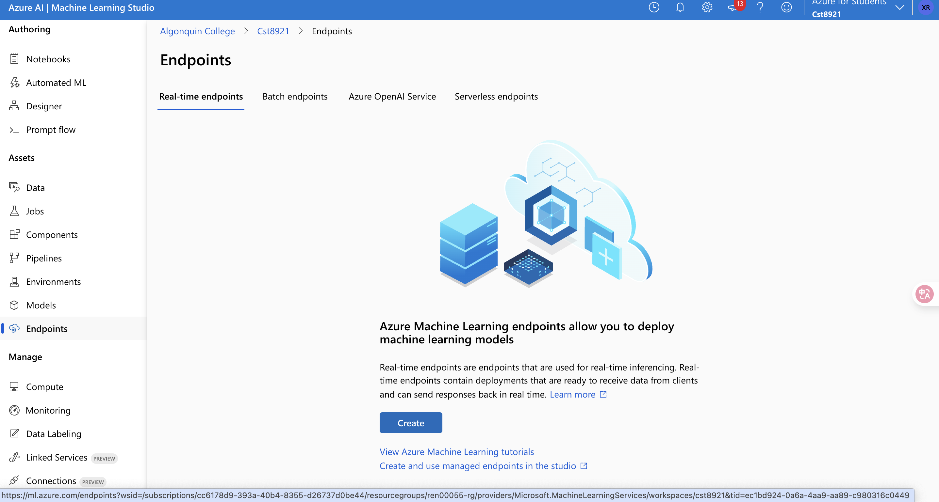

**Manage**

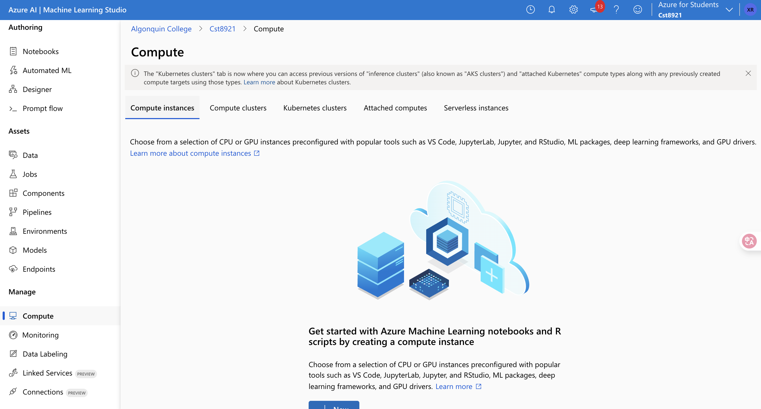

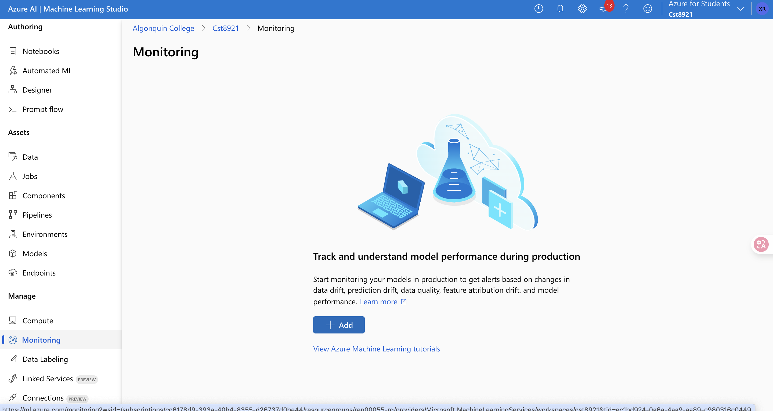

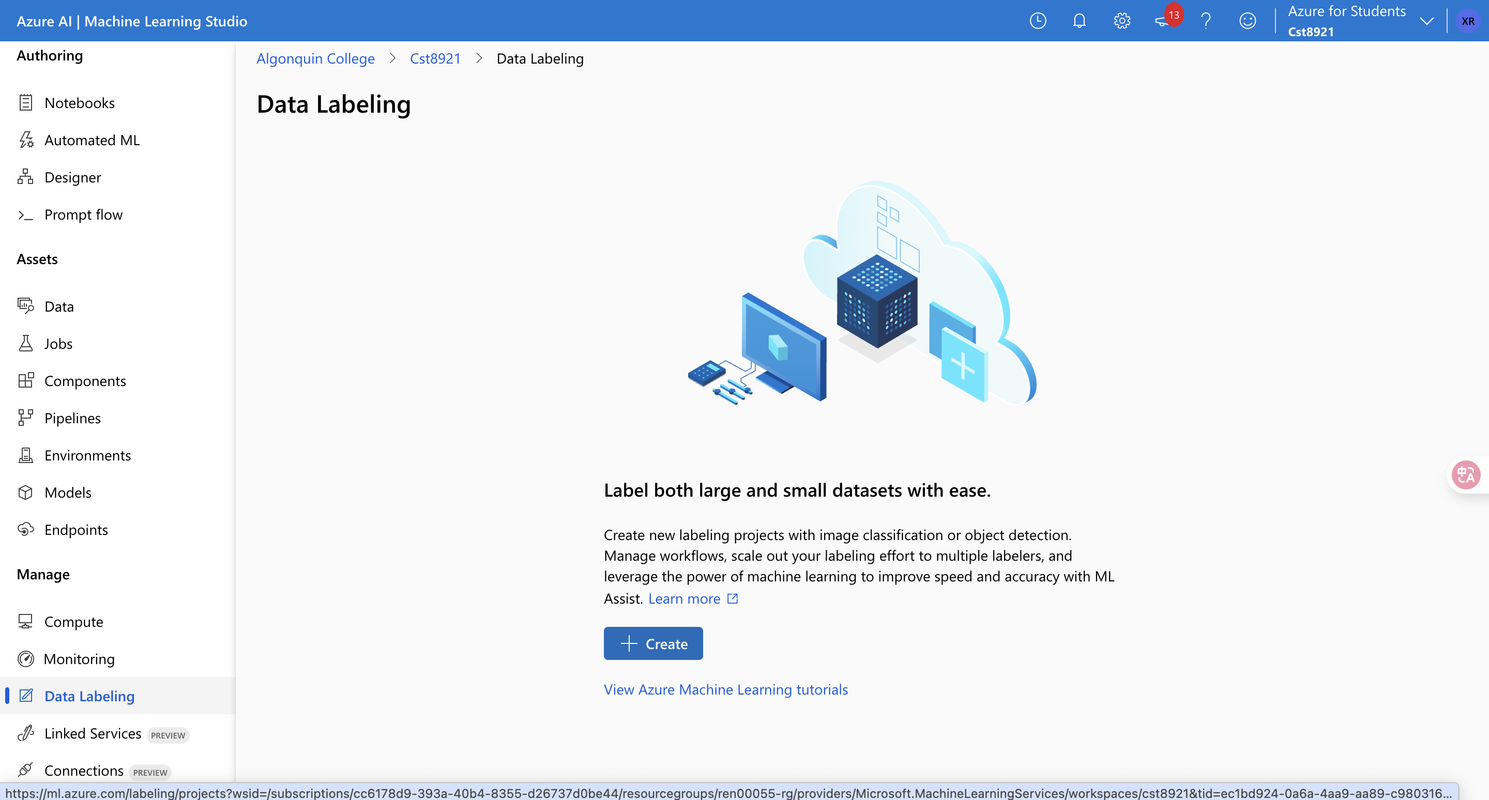

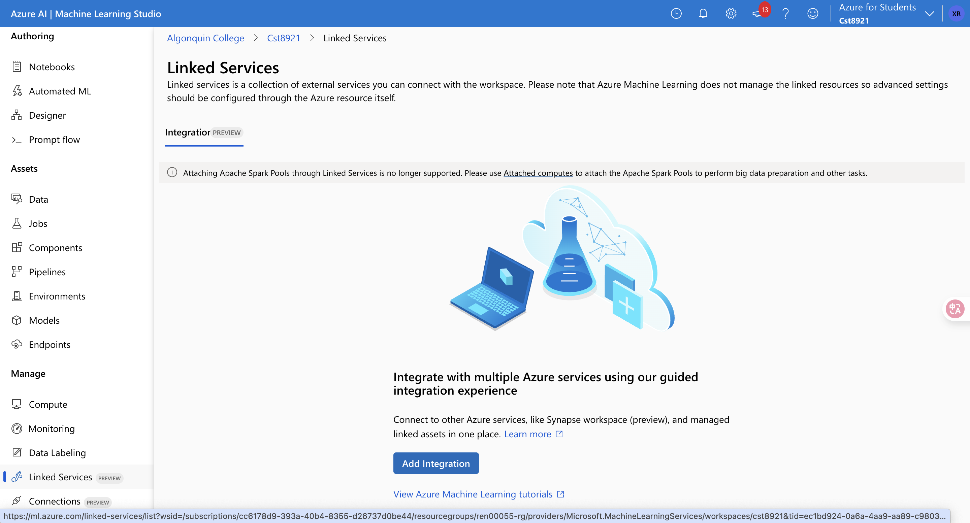

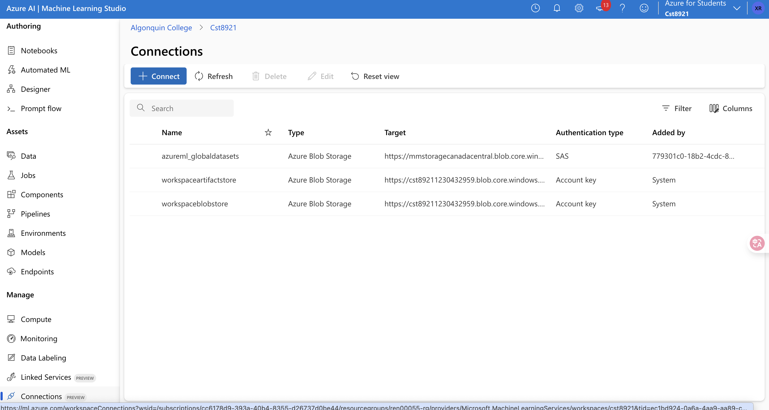

1. Create a compute instance (Standard_DS11_v2).

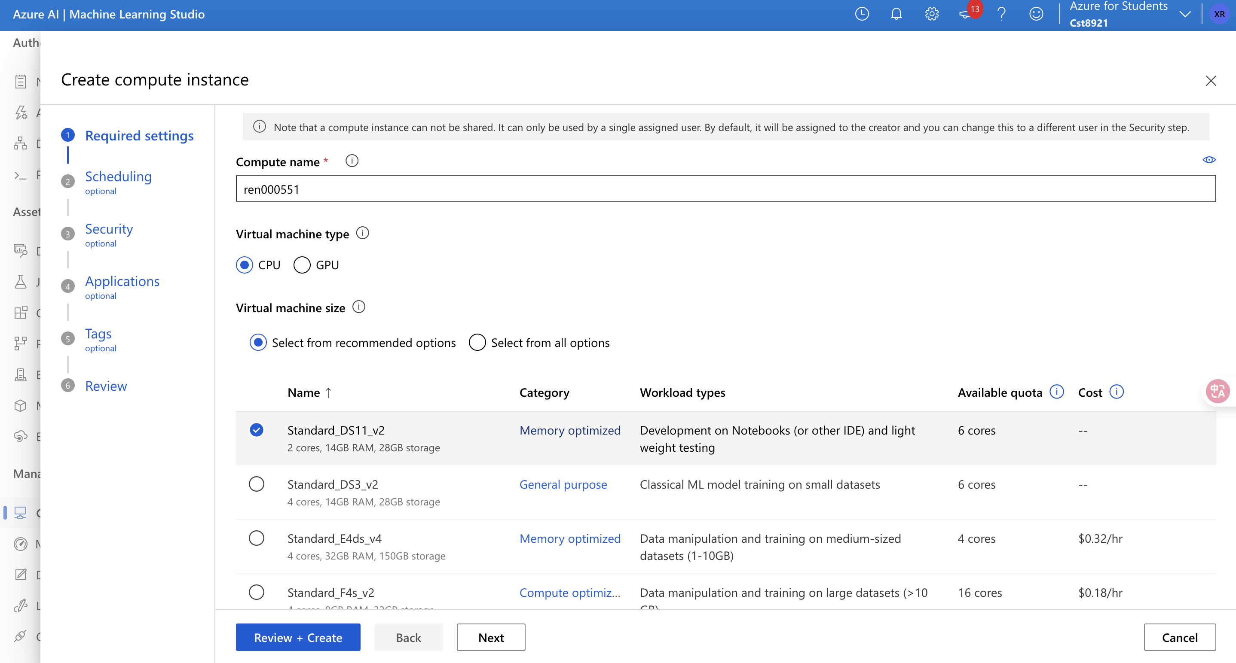

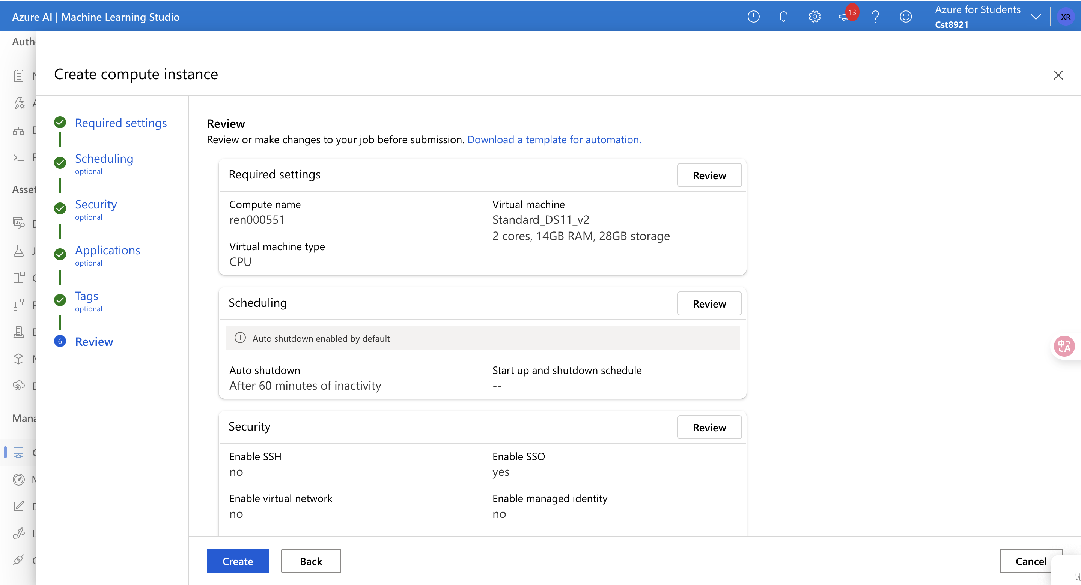

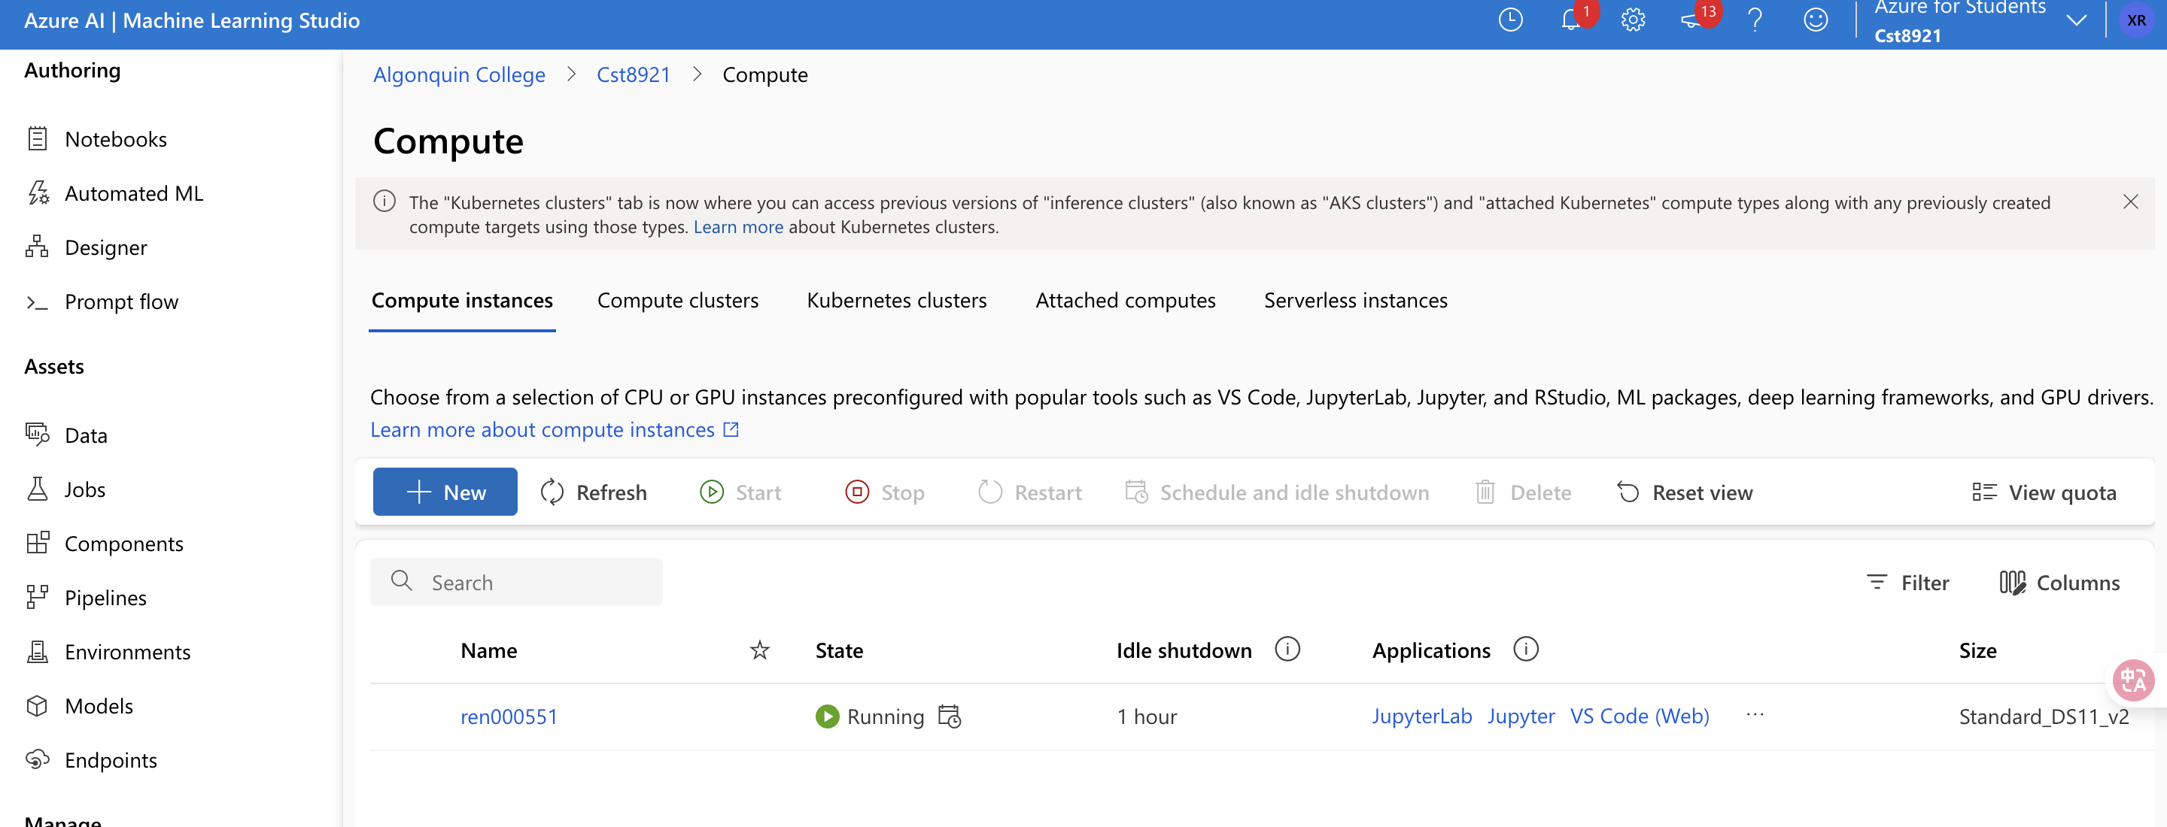

**Part 3: Build Your First ML Pipeline (AutoML OR Designer Option)**

**Goal:** Train a model using a low-code interface.  
**Options (student’s choice):**

* **Option A: Designer**  
  Use **Regression - Automobile Price Prediction** sample.
* **Option B: AutoML**  
  Upload a simple dataset (e.g., diabetes.csv) and let Azure AutoML find the best model.

**Tasks:**

* Run training pipeline or AutoML experiment.

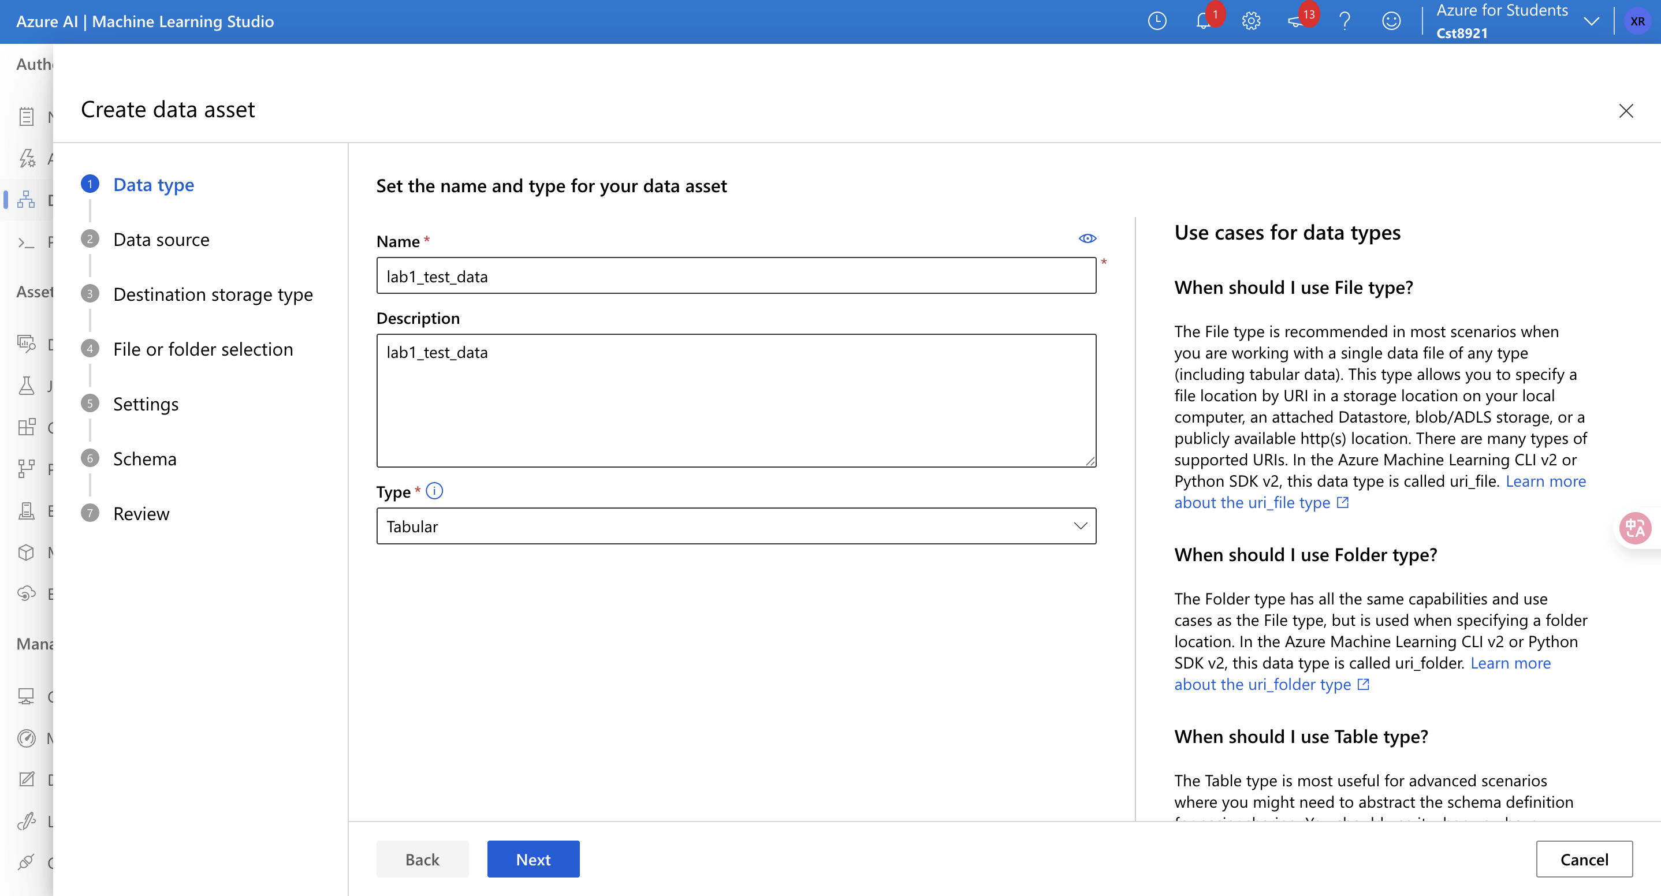

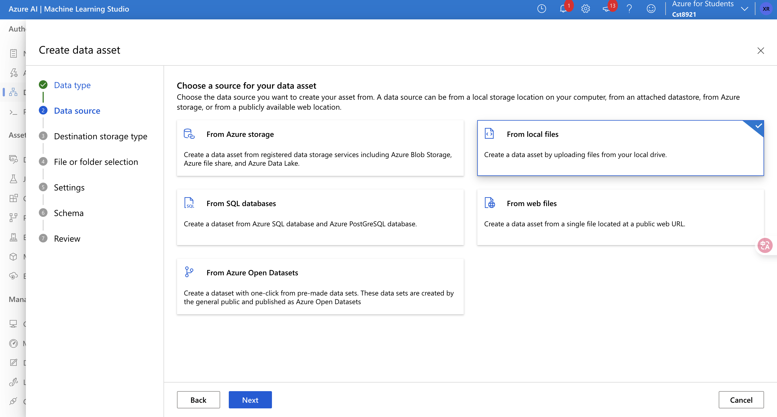

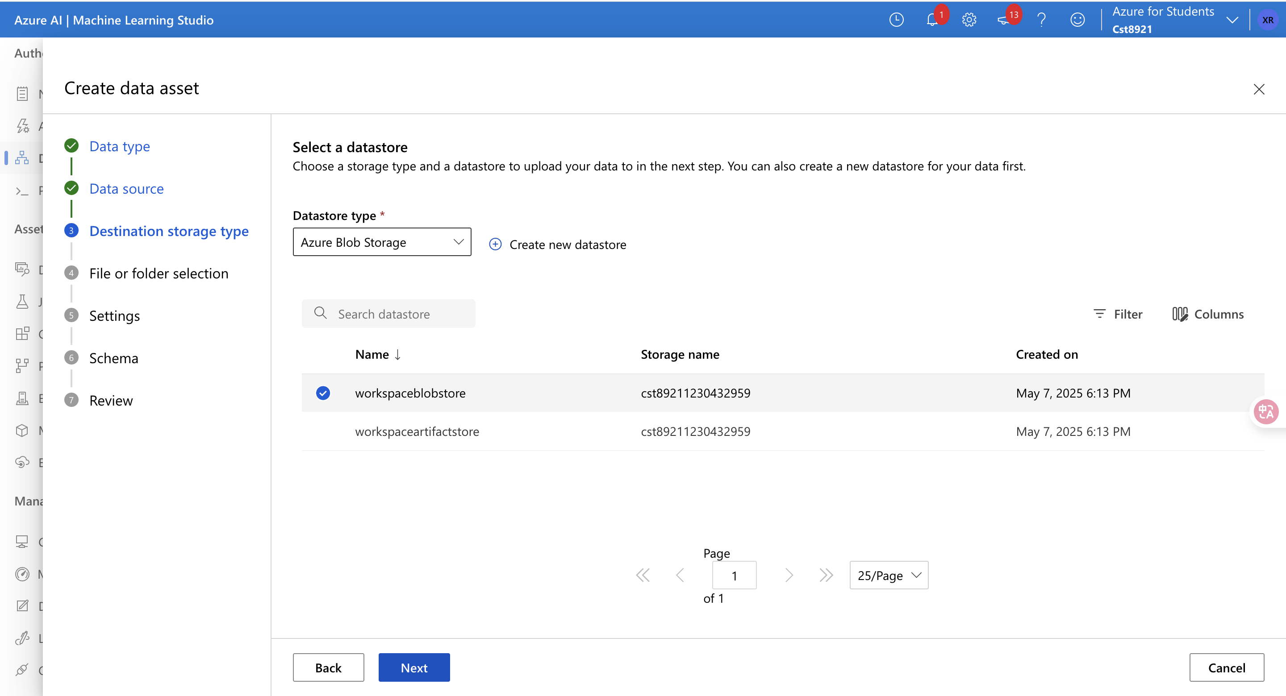

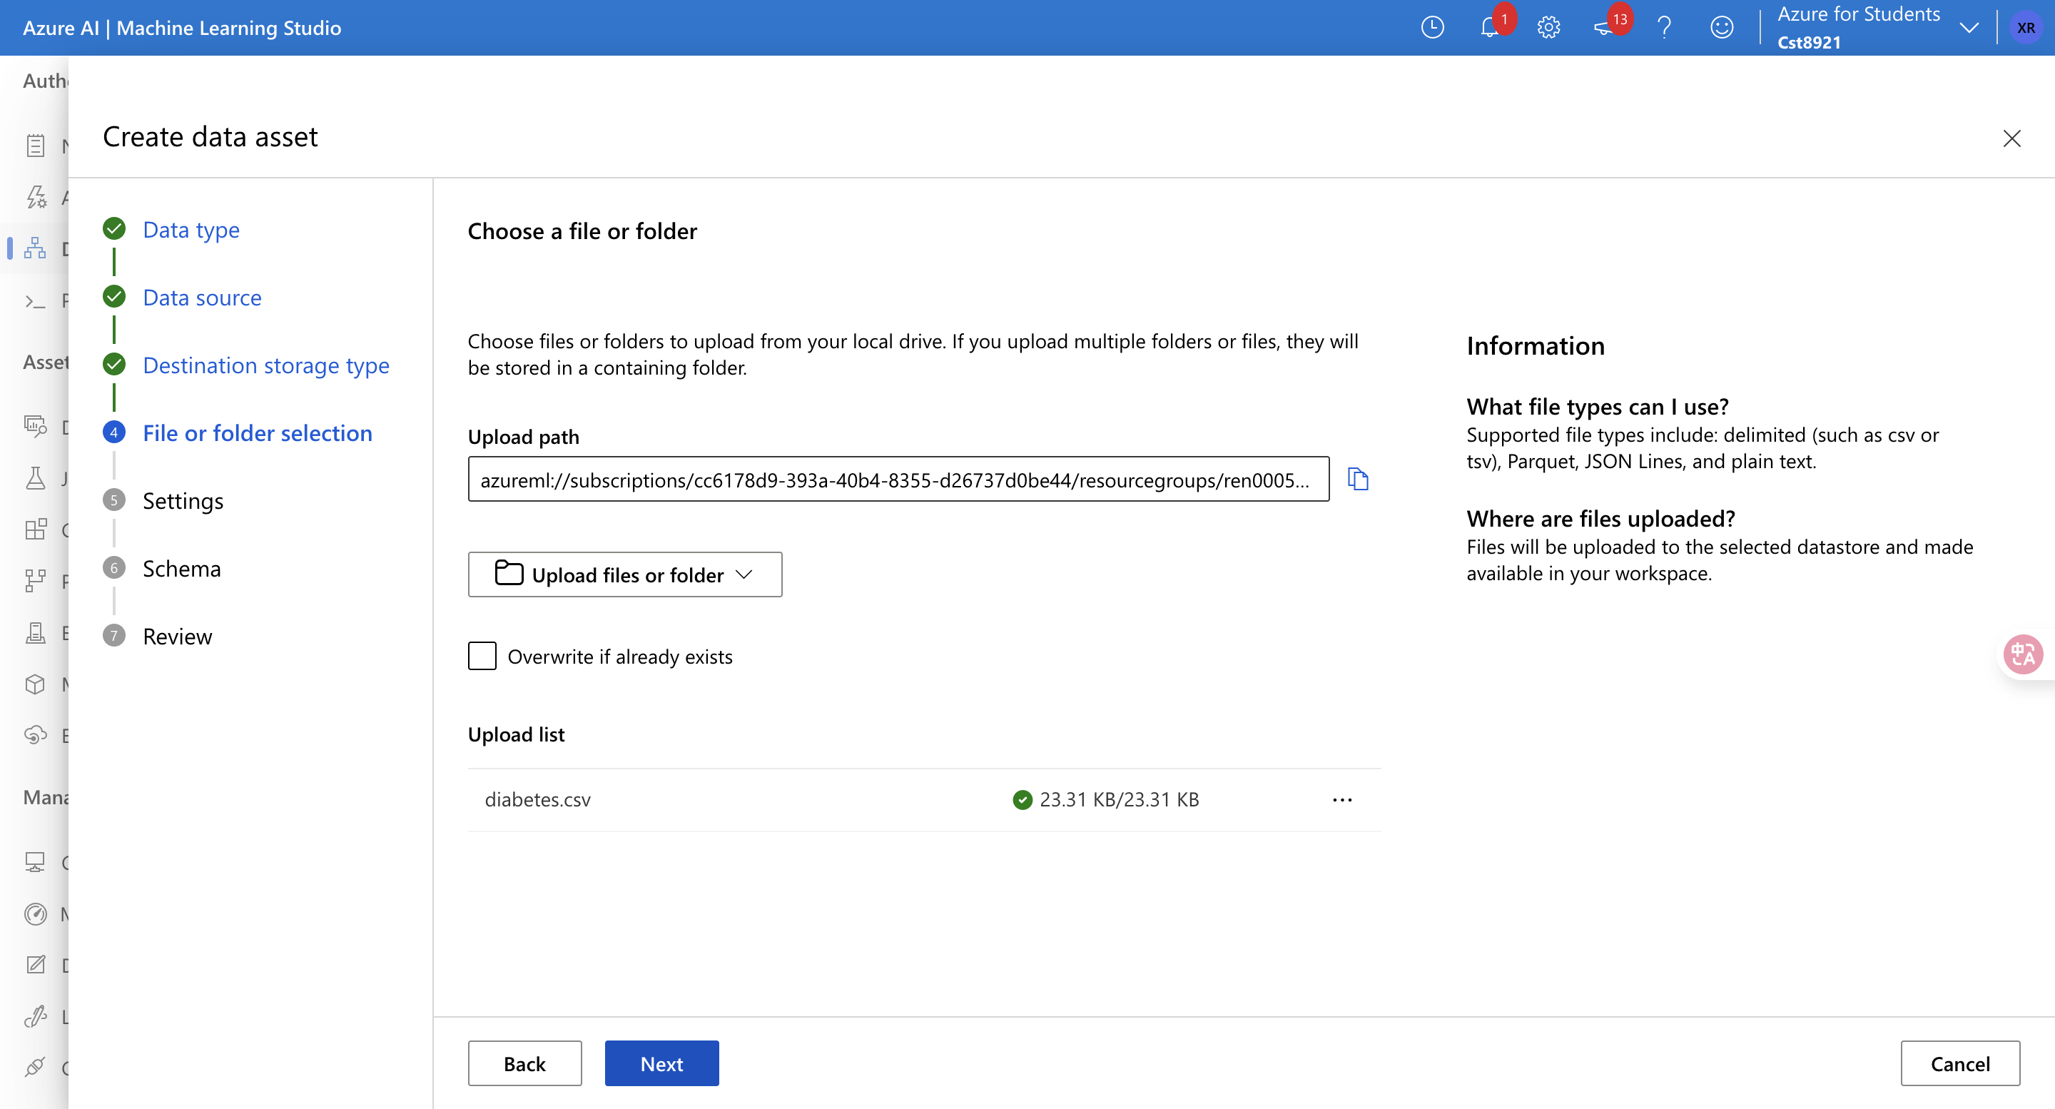

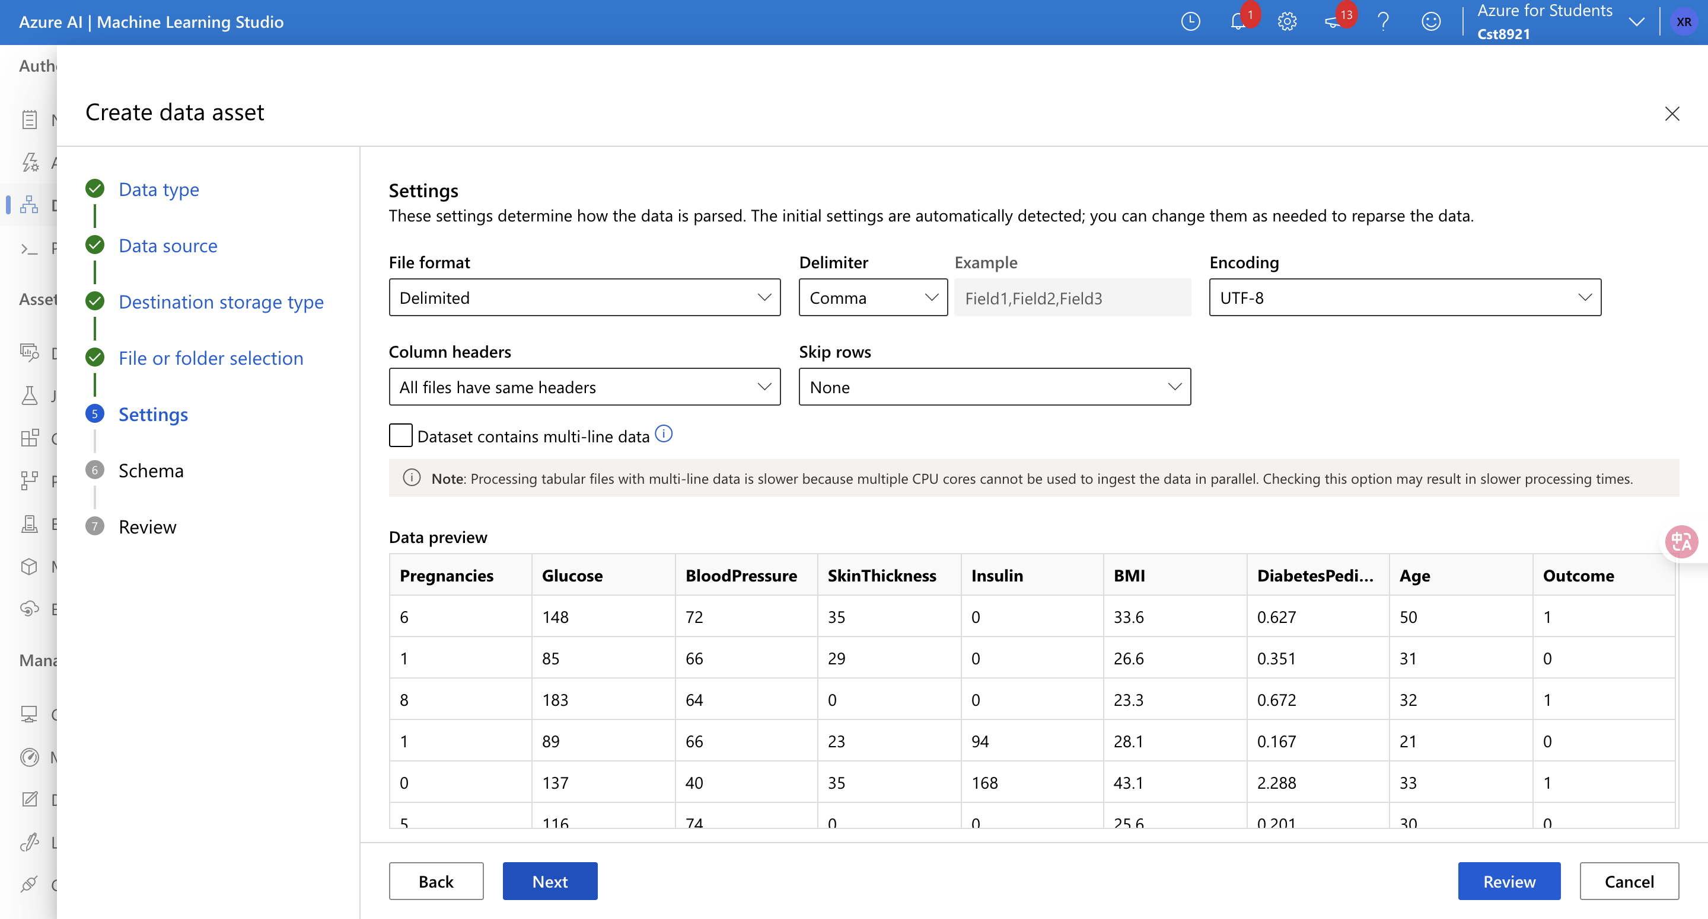

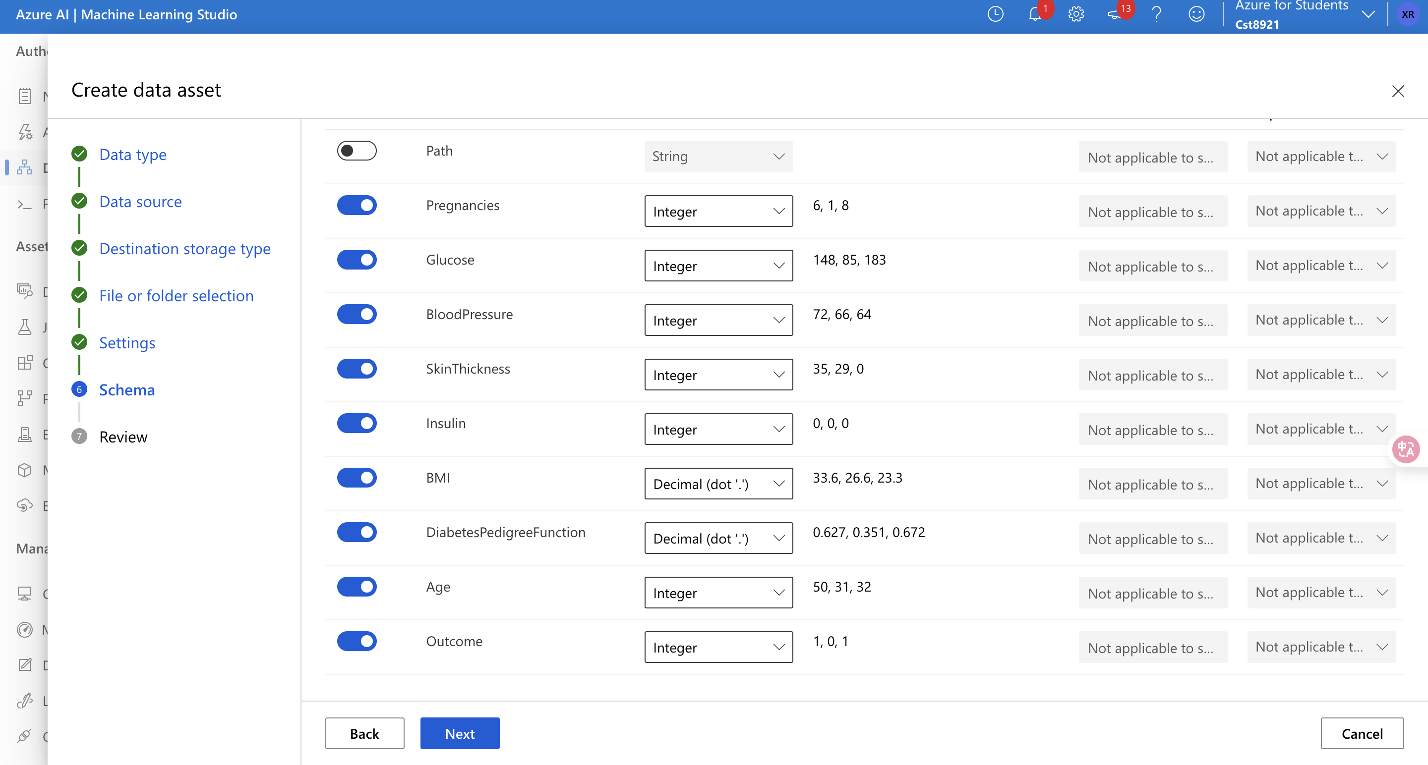

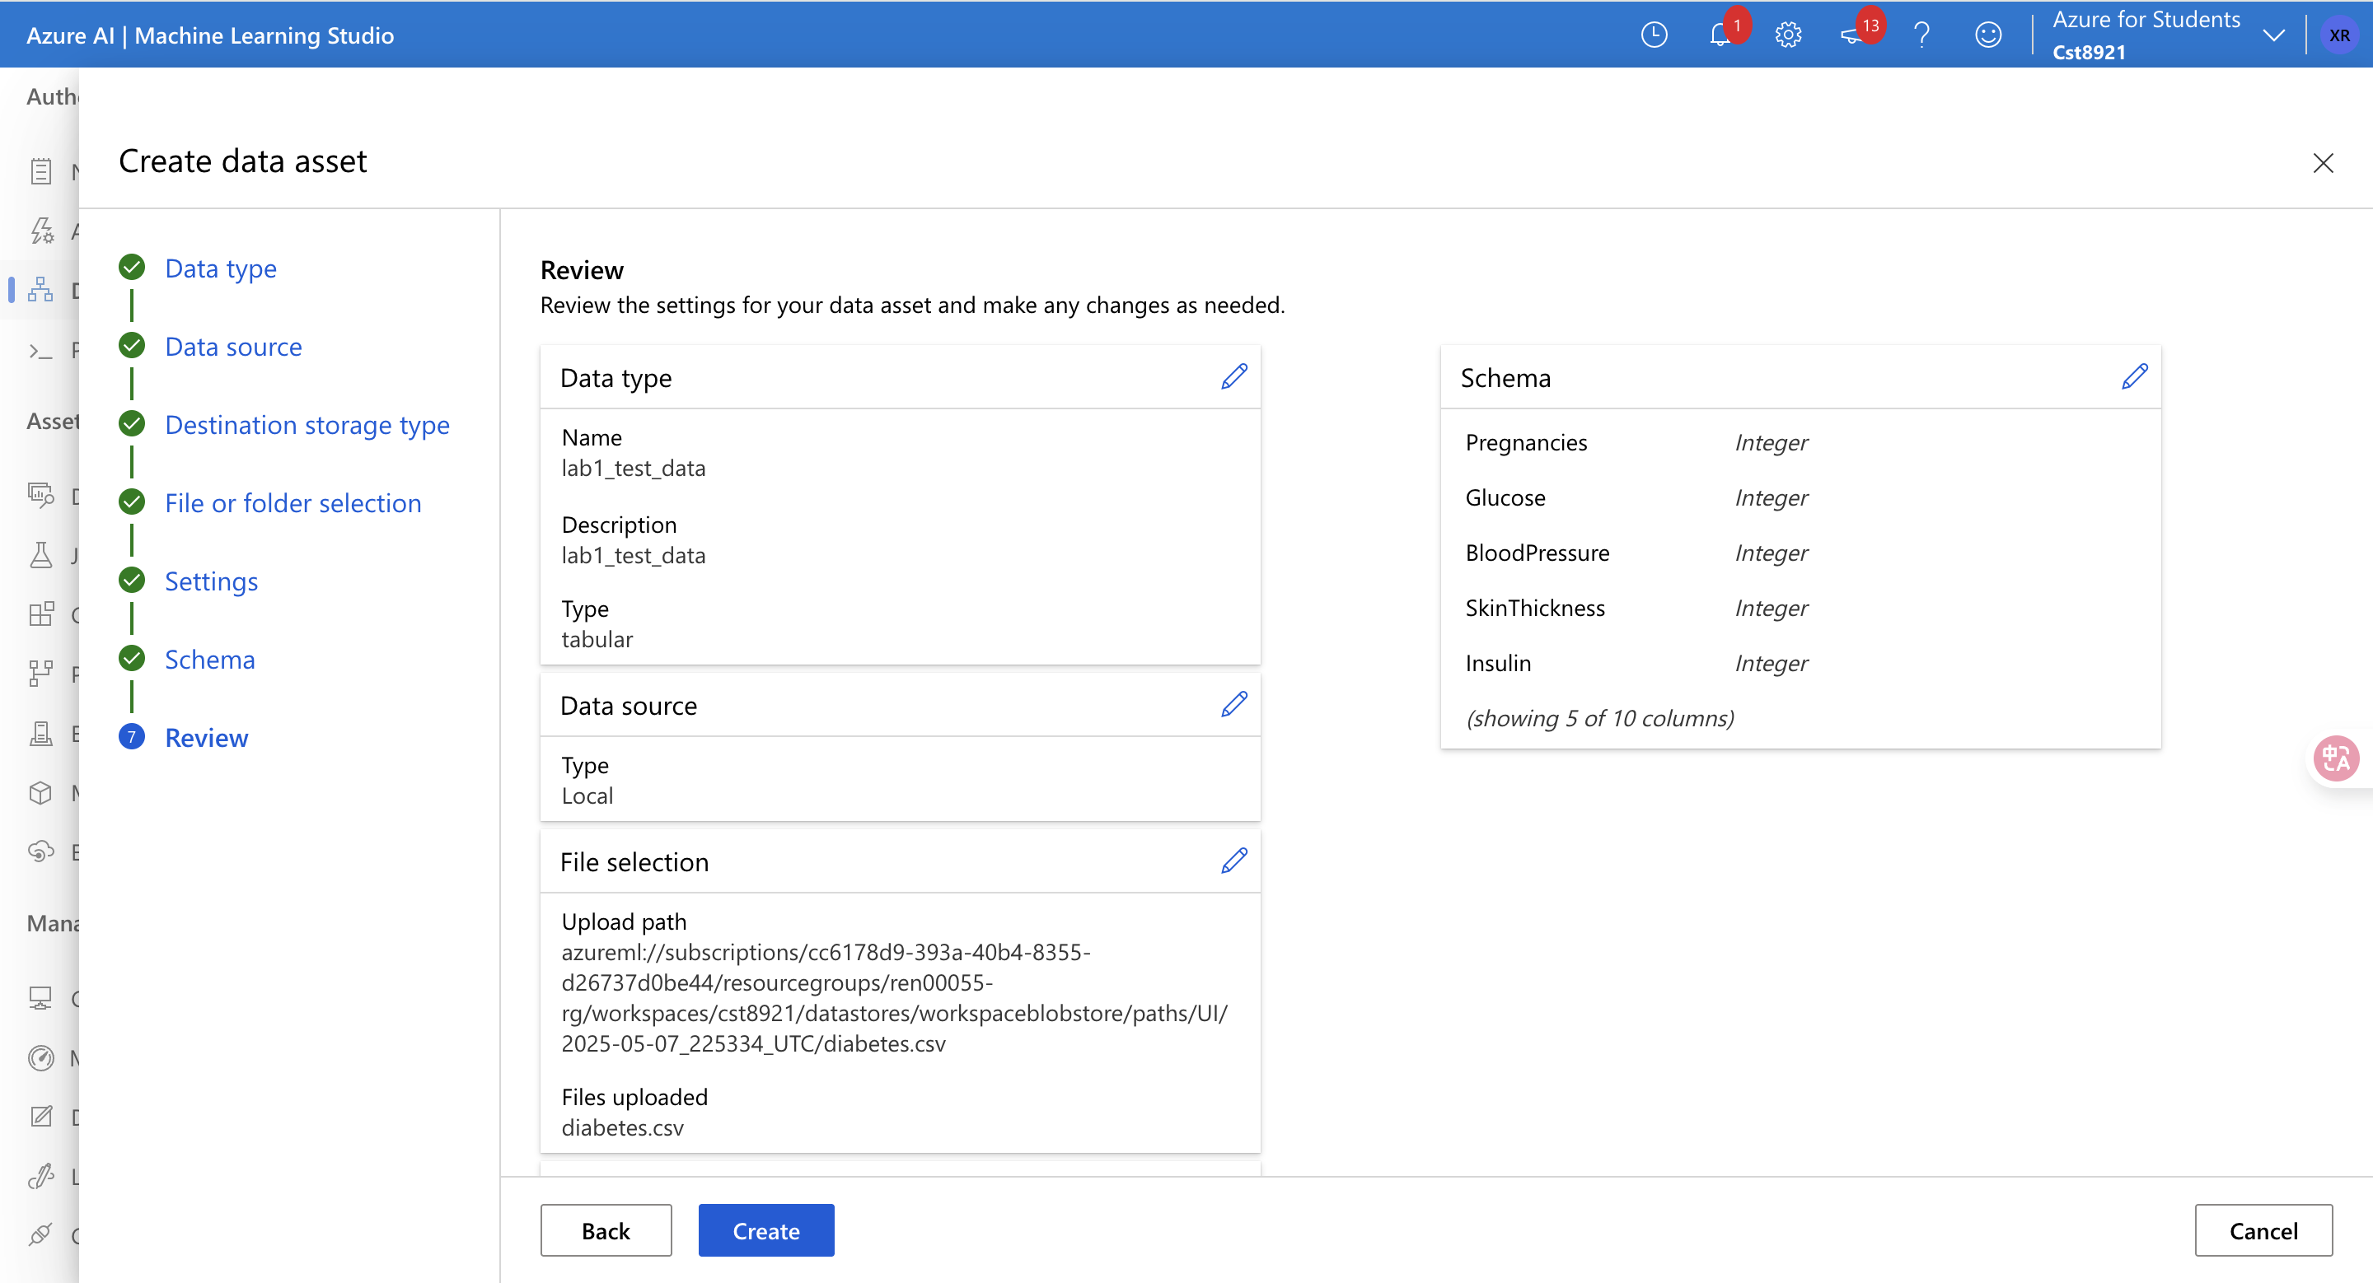

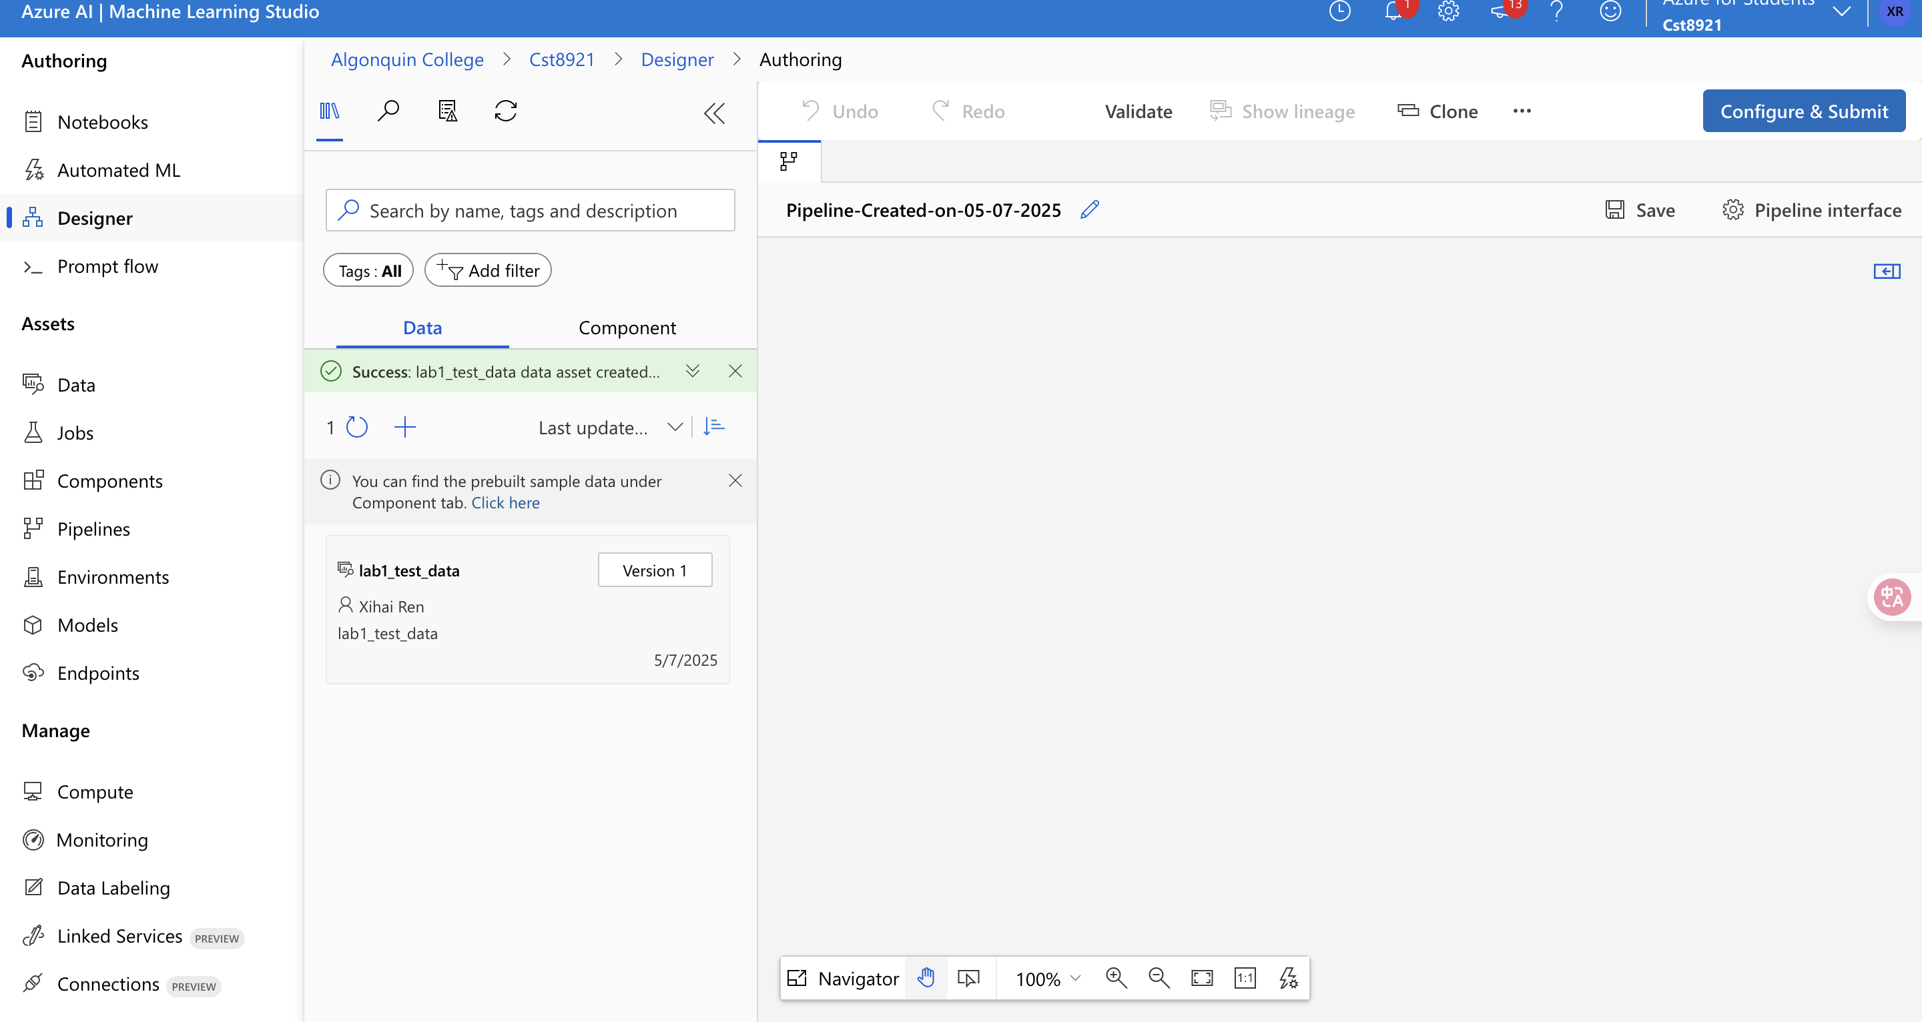

Set up pipeline job

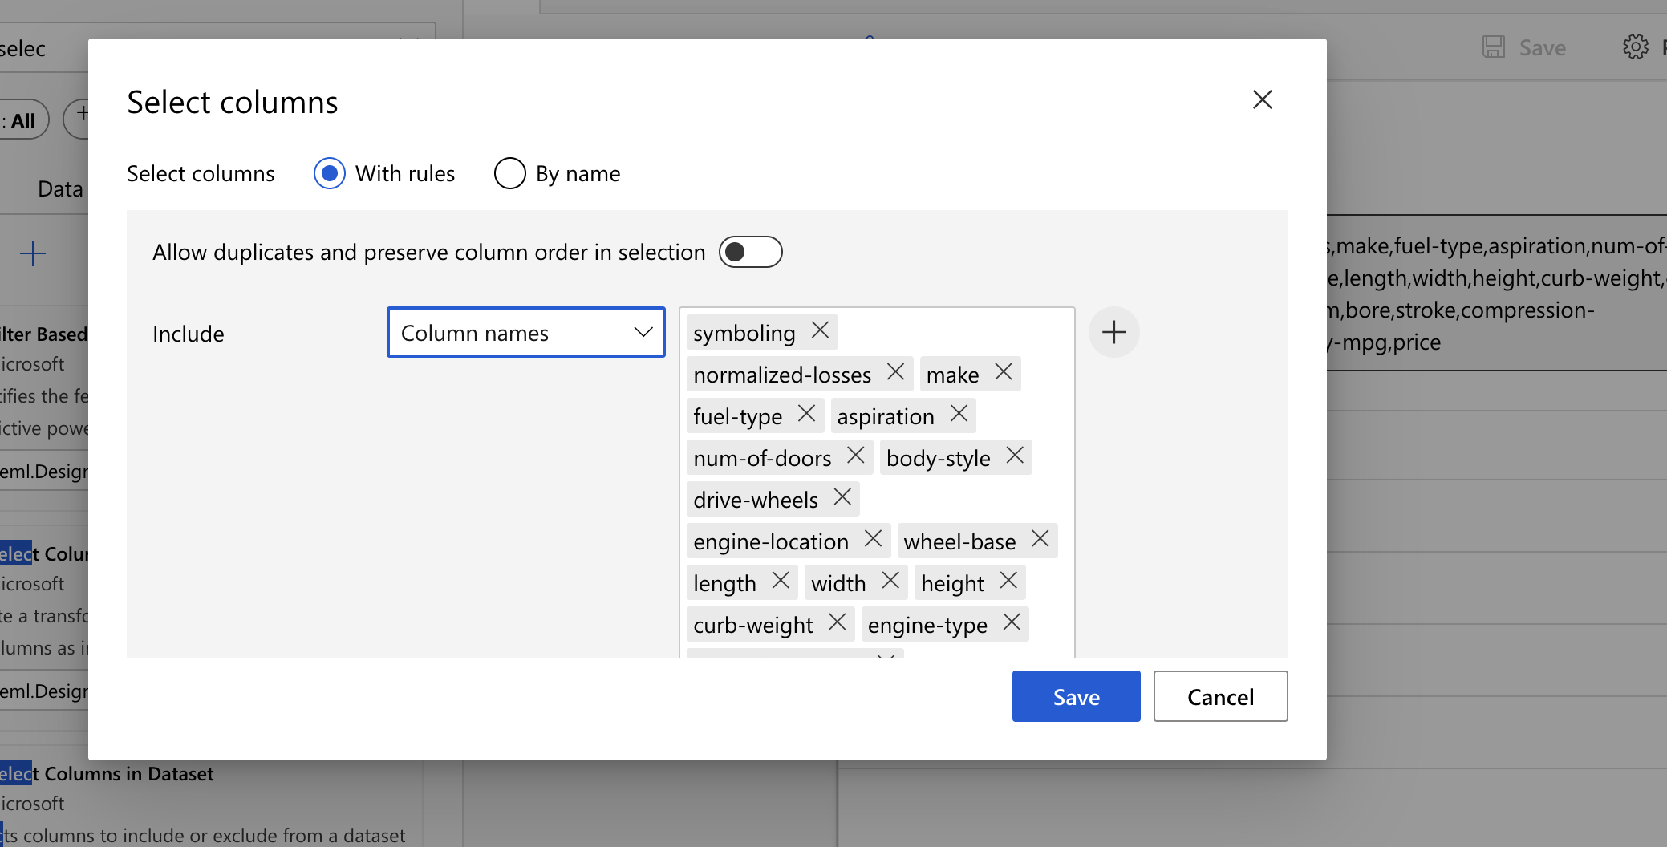

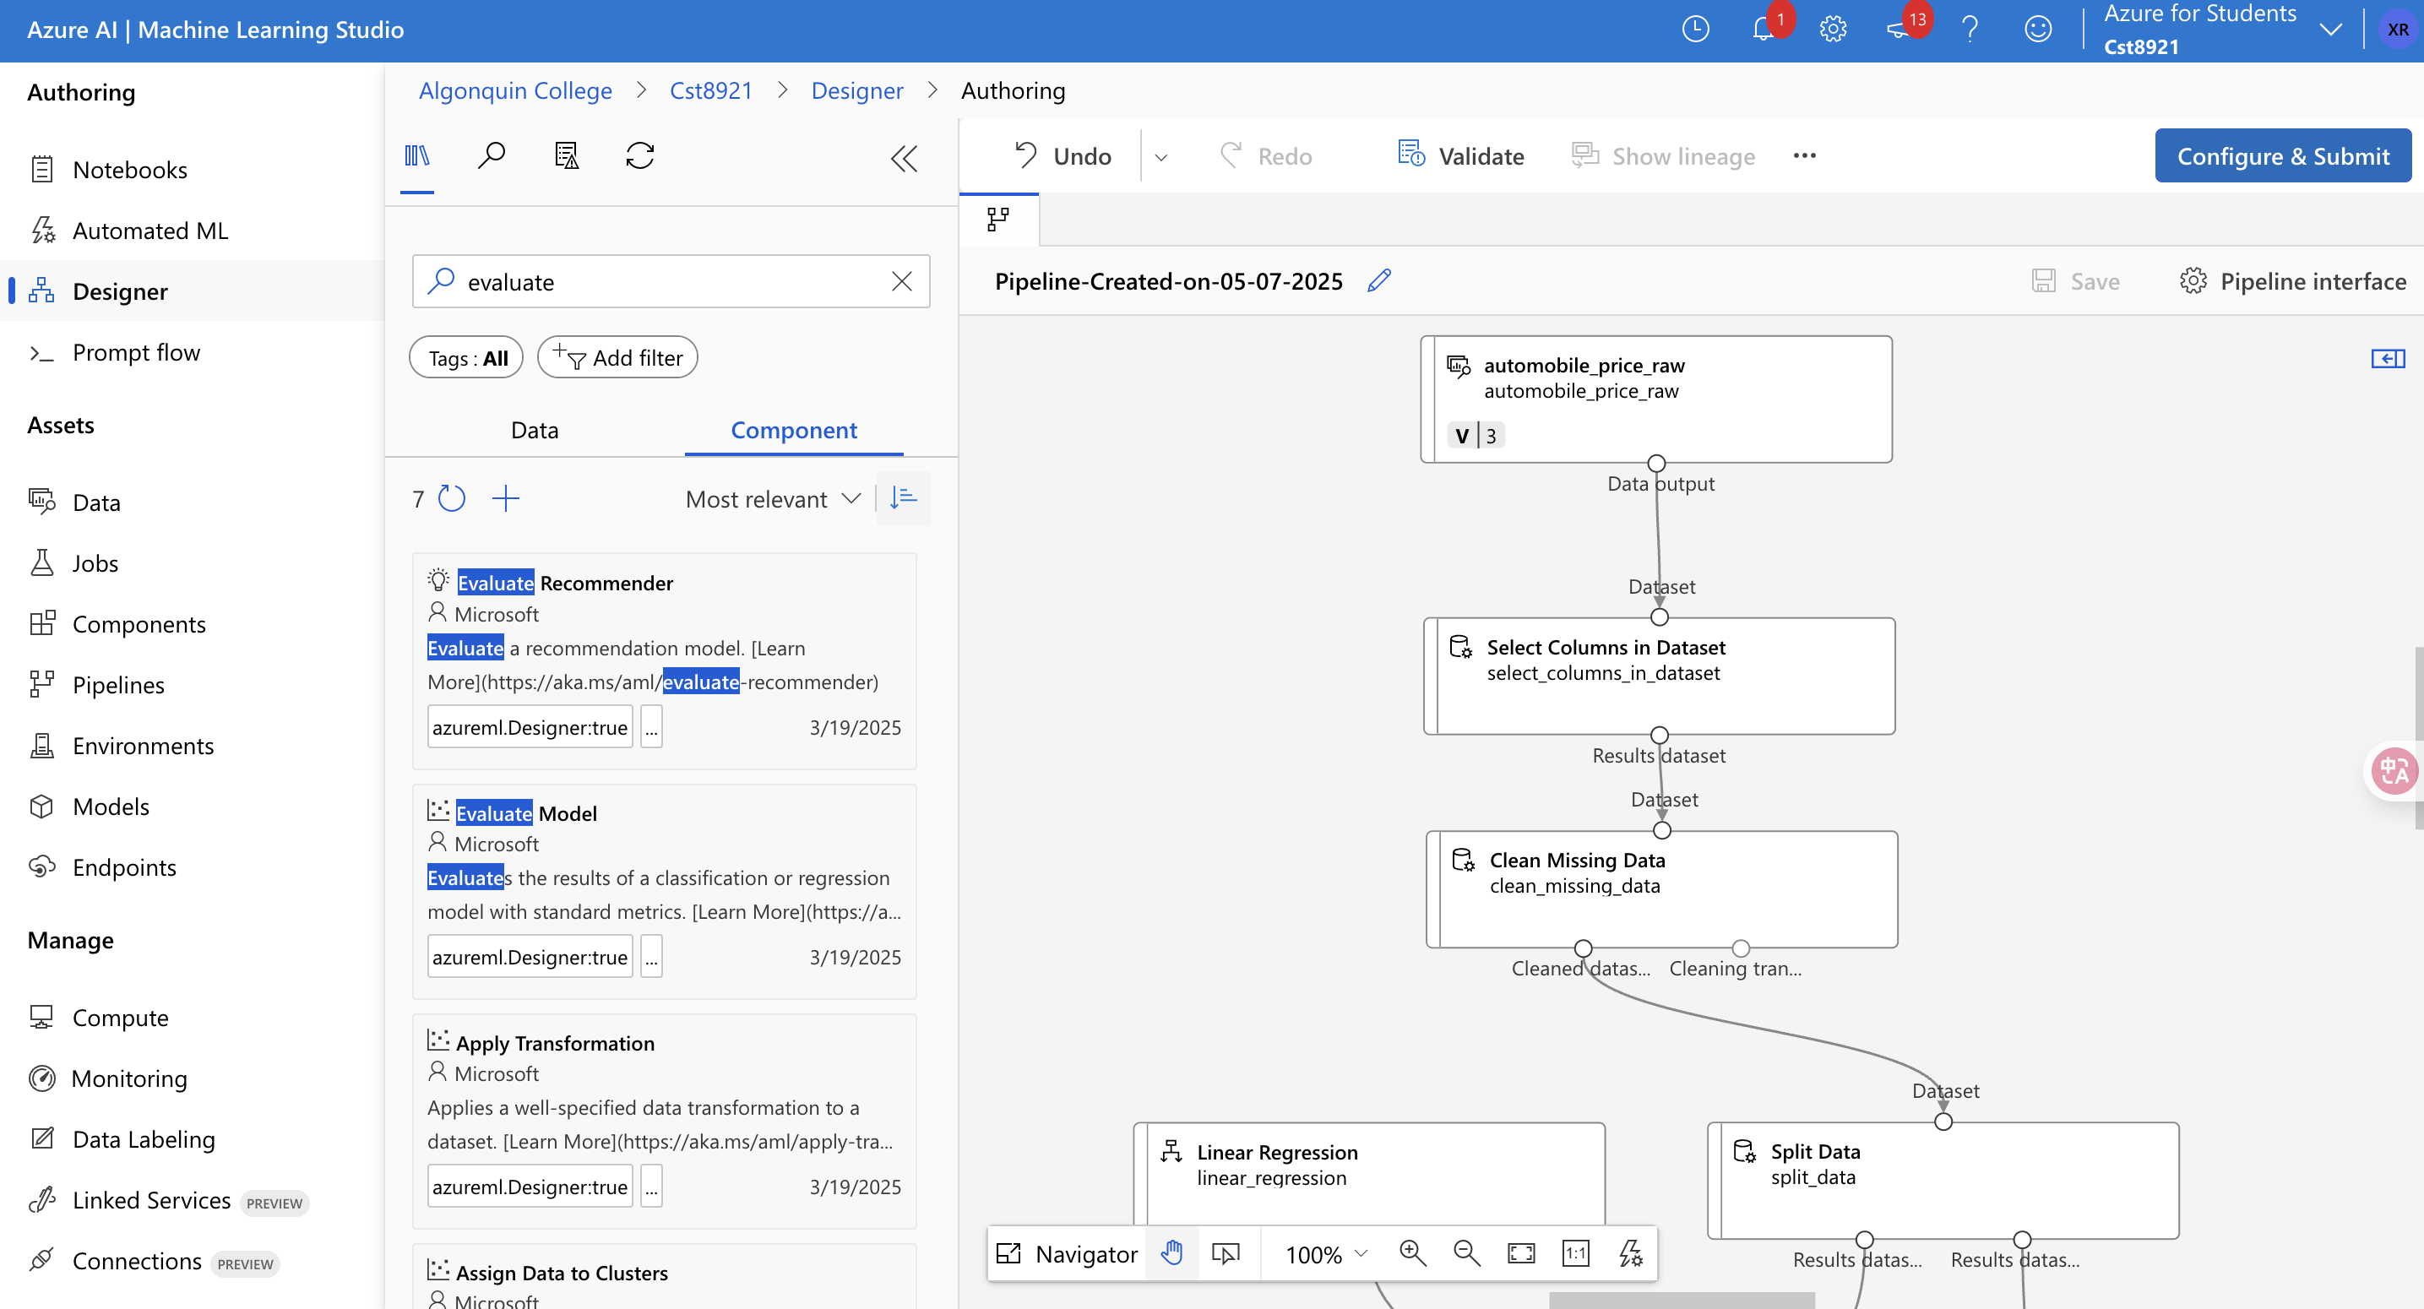

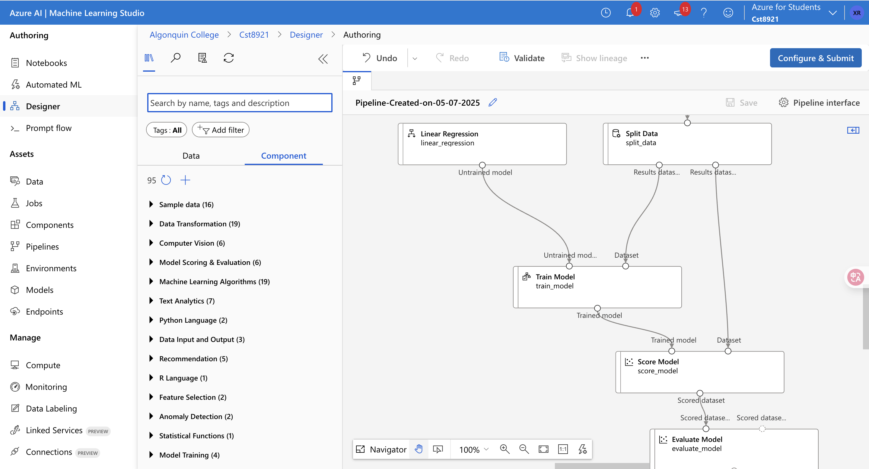

* Monitor execution using the **Jobs** tab.

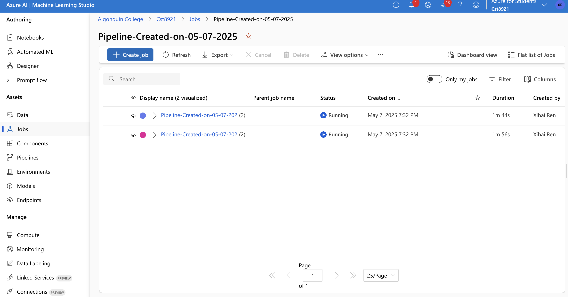

* Examine performance metrics.

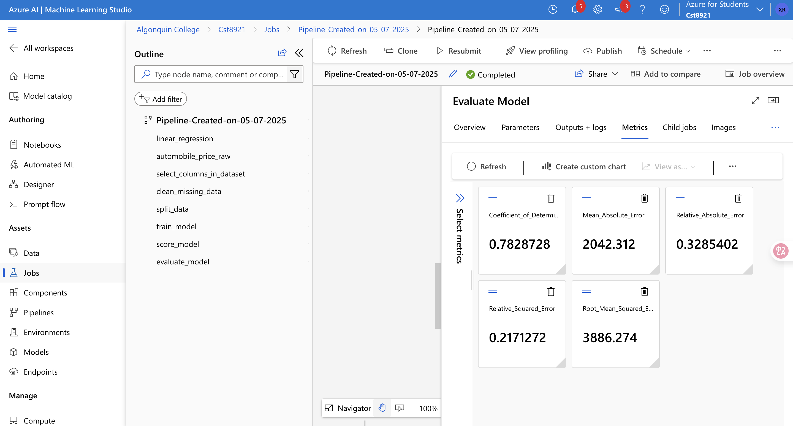

* Explore the training pipeline and key components.

Automobile_proce_raw

Select_columns_in_dataset

Clean_missing_data

Linear_regression

**Part 4: Clean Up and Report**

* Delete compute resources and workspace.
* Prepare a **lab report** with:
  + Design thinking output (problem statement + ML idea)
  + Screenshots of workspace, experiment, and output
  + Notes from the emerging trend modules
  + Reflections: What was easy, what was hard, and what was surprising?

**Lab Deliverables**

Submit a report in Brightspace with:

* Team idea summary (from design session)
* Individual screenshots and output